

**CSE2015 Data Analysis And Visualization**

**PROJECT TITLE: Visualizing Images And 3D Data**

Group Members:

1.Matli Mokshagni 20211ISD0038

2.Medam Sivamani 20211ISD0013

3.Gajjala Akhila 20211ISD0015

4.Abhi C N 20211ISD0039

5.Sunku Sai Yaswanth 20211ISD0007

6.Suguna Sree 20211IST0002

7.Huzaifa Sharif 20211IST0003

8.Sruthi Kumari 20211IST0014

9.Taman Preeth Kaur 20211IST0013

10.Methaji 20191IST0091

UNDER GUIDANCE OF:

Selvaraj Poornima

Dept:CSE

**TABLE OF CONTENT**

|  |  |  |
| --- | --- | --- |
| S.NO | TOPIC |  |
| 1 | Introduction To Visualizing Images And 3D Data |  |
| 2 | Basic Concepts Of Image And 3D Data Visualization |  |
| 3 | Image Visualization Techniques |  |
| 4 | 3D Visualization Techniques |  |
| 5 | Visualization Libraries For Images And 3D Data |  |
| 6 | Best Practices For Visualizing Images And 3D Data |  |
| 7 | Applications of Images And 3D Data Visualization |  |
| 8 | Conclusion |  |

Abstract:

Visualization plays a crucial role in understanding complex data, particularly in fields such as computer vision and 3D data analysis. This abstract delves into the various techniques and applications for visualizing images and three-dimensional (3D) data.

In the realm of image visualization, techniques range from simple methods like color mapping and histogram equalization to advanced approaches such as convolutional neural network (CNN) visualization and saliency mapping. These techniques enable researchers and practitioners to interpret image features, understand model decisions, and enhance the interpretability of image-based systems.

In the domain of 3D data visualization, the challenges intensify due to the increased complexity and dimensionality of the data. Techniques like volume rendering, isosurfacing, and surface rendering are commonly used to visualize volumetric and geometric 3D data. Additionally, advancements in virtual reality (VR) and augmented reality (AR) technologies have opened up new avenues for immersive visualization experiences, enabling users to interact with 3D data in intuitive and realistic ways.

Furthermore, the applications of visualizing images and 3D data are diverse and impactful. In medical imaging, visualization techniques aid in diagnosing diseases, planning surgeries, and conducting research. In robotics and autonomous systems, visualizing sensor data is essential for navigation, object recognition, and scene understanding. In entertainment and gaming industries, realistic rendering and interactive 3D visualization enhance user experiences and drive innovation.

In conclusion, the effective visualization of images and 3D data is essential for gaining insights, making informed decisions, and pushing the boundaries of various fields. Continued research and development in visualization techniques and technologies promise to unlock new possibilities and applications, driving progress in science, engineering, and beyond.

Introduction:

In the age of big data, the ability to effectively interpret and understand complex information is becoming increasingly vital. Nowhere is this more evident than in the domains of image processing and three-dimensional (3D) data analysis. The sheer volume and intricacy of visual data generated by modern technologies demand sophisticated visualization techniques to extract meaningful insights. This introduction provides an overview of the importance, challenges, and advancements in visualizing images and 3D data.

Images are ubiquitous in our digital landscape, captured by cameras, sensors, and various imaging devices. Whether in medical diagnostics, autonomous vehicle navigation, or satellite imagery analysis, images convey rich information that holds immense value for decision-making and understanding. However, the raw pixel data of images often conceals intricate patterns and structures that require specialized visualization methods to reveal.

Similarly, 3D data presents its own set of challenges. From volumetric medical scans to geometric models in computer-aided design (CAD) software, 3D data encapsulates spatial relationships and detailed geometry that traditional 2D representations struggle to convey adequately. Visualizing 3D data involves techniques that go beyond simple projections, requiring advanced algorithms for rendering, surface extraction, and interactive exploration.

The evolution of visualization techniques for images and 3D data has been closely intertwined with technological advancements. Machine learning, particularly deep learning, has revolutionized image understanding, enabling computers to discern objects, scenes, and patterns with remarkable accuracy. Visualization methods tailored to deep learning models provide insights into their decision-making processes, fostering trust and interpretability.

In the realm of 3D data, the convergence of hardware innovations like graphics processing units (GPUs) and software developments in computer graphics has fueled remarkable progress. Real-time rendering engines, physically-based rendering algorithms, and virtual reality (VR) environments offer immersive experiences for exploring complex 3D datasets. Moreover, interdisciplinary collaborations between computer scientists, mathematicians, and domain experts have enriched the toolbox of visualization techniques with insights from diverse fields.

Despite these advancements, challenges persist. The scale and complexity of visual data continue to outpace the capabilities of existing visualization methods. Scalability, interactivity, and interpretability remain pressing concerns, particularly as datasets grow larger and more diverse. Additionally, ensuring the ethical and responsible use of visualization techniques, especially in sensitive domains like healthcare and surveillance, requires careful consideration.

In light of these challenges, this paper explores the state-of-the-art techniques and applications for visualizing images and 3D data. From fundamental principles to cutting-edge research, understanding how to extract insights from visual data is crucial for unlocking its full potential across various domains. By addressing the current landscape and future directions in visualization, we aim to inspire further innovation and empower researchers and practitioners to harness the power of visual data effectively.

Certainly, let's delve deeper into the significance of visualizing images and 3D data.

In the context of images, visualization serves as a bridge between raw pixel data and human comprehension. While computers excel at processing vast amounts of pixel information, humans rely on visual patterns and context to make sense of images intuitively. Visualization techniques help bridge this gap by transforming pixel data into interpretable representations, highlighting meaningful features, and enabling domain experts to extract valuable insights efficiently.

For instance, in medical imaging, visualization plays a crucial role in diagnosing diseases, planning treatments, and monitoring patient outcomes. Techniques such as multi-modal image fusion, where data from different imaging modalities like MRI, CT, and PET are combined and visualized synergistically, enhance diagnostic accuracy and aid in surgical planning. Similarly, in remote sensing and environmental monitoring, satellite imagery visualization helps scientists track changes in land use, detect environmental hazards, and assess the impact of climate change.

Moreover, the advent of deep learning has revolutionized image analysis by enabling computers to learn complex patterns directly from data. However, the "black-box" nature of deep learning models raises concerns regarding their transparency and interpretability. Visualization techniques such as activation maximization, gradient-based attribution methods, and feature visualization provide insights into how deep learning models make predictions, fostering trust and enabling domain experts to validate model decisions.

Turning to 3D data, the challenges and opportunities are even more pronounced. From architectural design to geological modeling, 3D data encapsulates spatial relationships and geometric intricacies that are inherently three-dimensional. Traditional 2D representations often fall short in capturing the richness of 3D data, necessitating specialized visualization techniques to unlock its full potential.

In fields like material science and molecular modeling, visualizing 3D structures at atomic or molecular scales is essential for understanding chemical properties, predicting material behavior, and designing novel compounds. Techniques such as molecular dynamics simulations coupled with interactive visualization tools enable researchers to explore complex molecular structures in real-time, accelerating drug discovery and materials design processes.

Furthermore, the rise of 3D scanning technologies, such as LiDAR and structured light scanning, has democratized the creation of 3D models from real-world objects and environments. Visualization techniques for point clouds, meshes, and volumetric data enable applications ranging from cultural heritage preservation to industrial quality control. By visualizing and analyzing 3D data, archaeologists can digitally reconstruct ancient artifacts, engineers can inspect complex components for defects, and urban planners can simulate cityscapes for better design decisions.

In conclusion, the importance of visualizing images and 3D data cannot be overstated. From enhancing medical diagnostics to enabling scientific discoveries, visualization techniques empower researchers and practitioners to extract insights, make informed decisions, and communicate complex information effectively. By continually advancing the state-of-the-art in visualization, we pave the way for new discoveries, innovations, and applications across diverse domains, shaping the future of visual computing and data analysis.

Certainly, let's explore additional facets of visualizing images and 3D data.

1. **Interactive Visualization**: One of the key challenges in visualizing complex data lies in facilitating interactive exploration. Interactive visualization tools empower users to manipulate, filter, and analyze visual data in real-time, enabling iterative exploration and hypothesis testing. Techniques such as brushing and linking, zooming and panning, and dynamic query mechanisms provide users with intuitive means to interact with large-scale image and 3D datasets, fostering deeper understanding and discovery.

2. **Multi-resolution Visualization**: Image and 3D data often exhibit multi-scale structures, ranging from fine details to coarse features. Multi-resolution visualization techniques adaptively adjust the level of detail based on user interactions or data characteristics, ensuring that relevant information is presented at the appropriate scale. Hierarchical representations, multi-scale rendering algorithms, and level-of-detail techniques enable efficient visualization of large datasets while preserving essential details, facilitating comprehensive analysis and interpretation.

3. **Temporal Visualization**: In many applications, visual data evolves over time, capturing dynamic processes and temporal dependencies. Temporal visualization techniques enable the analysis of time-varying phenomena, facilitating the identification of patterns, trends, and anomalies. Time series visualization, spatiotemporal maps, and animated representations provide insights into temporal dynamics, supporting tasks such as climate modeling, financial analysis, and motion tracking.

4. **Uncertainty Visualization**: Visualizing uncertainty is crucial for conveying the reliability and confidence associated with visual data, especially in domains where uncertainty is inherent, such as medical imaging, climate modeling, and predictive analytics. Uncertainty visualization techniques, including probabilistic rendering, error bars, and uncertainty glyphs, communicate uncertainty information alongside visual data, aiding decision-making and risk assessment. By incorporating uncertainty-aware visualizations, users can make more informed judgments and mitigate potential risks associated with data interpretation.

5. **Collaborative Visualization**: Collaboration is increasingly prevalent in data analysis and decision-making processes, requiring visualization tools that support collaborative exploration and communication. Collaborative visualization environments facilitate real-time sharing and annotation of visual data among multiple users, regardless of geographical locations. Techniques such as distributed rendering, shared virtual environments, and collaborative annotation tools promote teamwork and knowledge exchange, fostering collective insights and consensus-building.

6. **Ethical Considerations**: As visualization technologies become more powerful and pervasive, ethical considerations surrounding data privacy, bias, and representation become paramount. Visualization practitioners and researchers must address ethical concerns related to data ownership, consent, and potential misuse of visualization techniques. Principles such as fairness, transparency, and accountability should guide the development and deployment of visualization systems, ensuring that they uphold ethical standards and respect the rights and dignity of individuals and communities.

**Fundamentals of Image and 3D Data**

**Visualization**

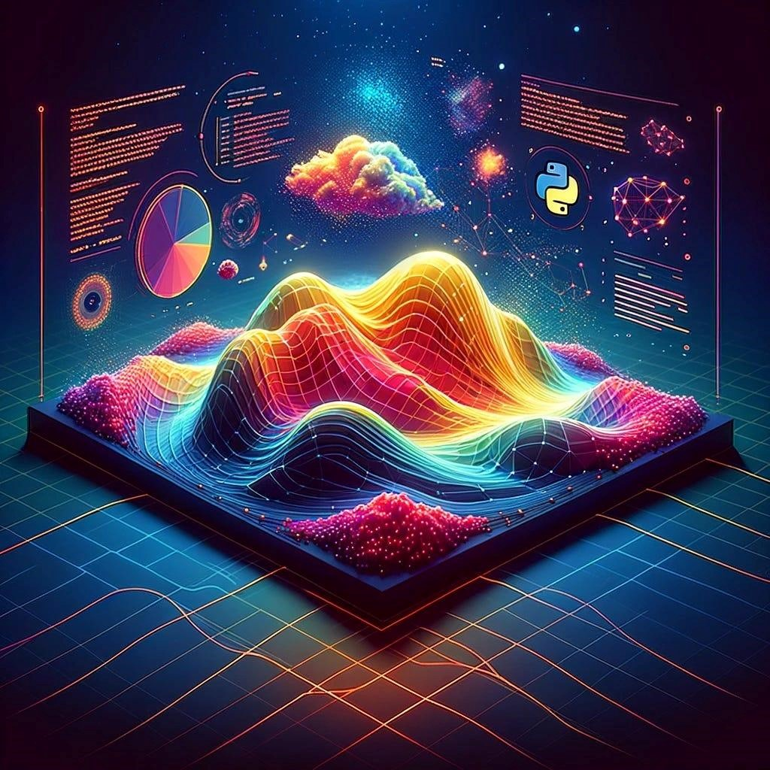

# Image Visualization

Pixels and Resolution:

* Pixels: Pixels are the smallest elements of a computer image, each representing a single point.
* Resolution: Resolution is the number of pixels along an image's dimensions (width and height), with higher resolutions delivering more detail.

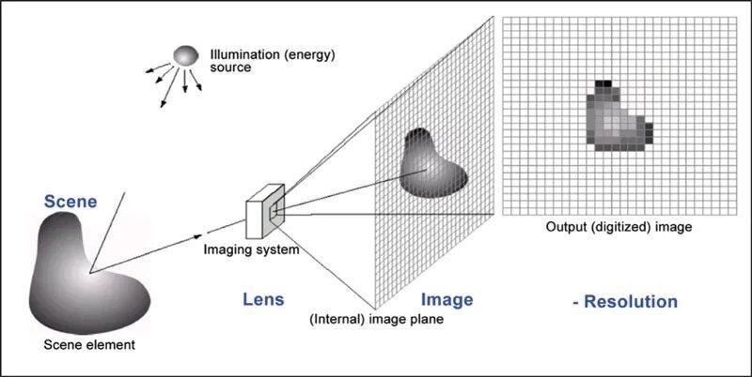

Color Models:

* RGB (Red, Green, Blue): A common concept for digital panels in which colors are created by combining these three primary colors.
* CMYK (Cyan, Magenta, Yellow, Black): Widely used in color printing. ● Grayscale: Indicates differences in intensity from black to white.

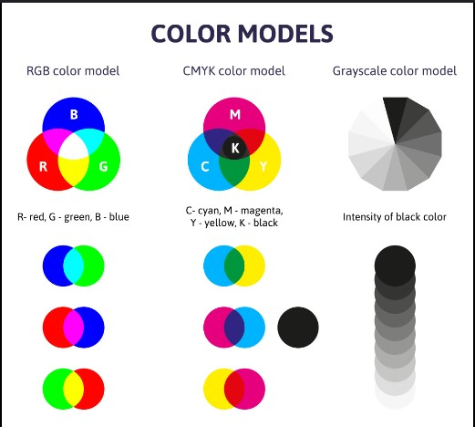

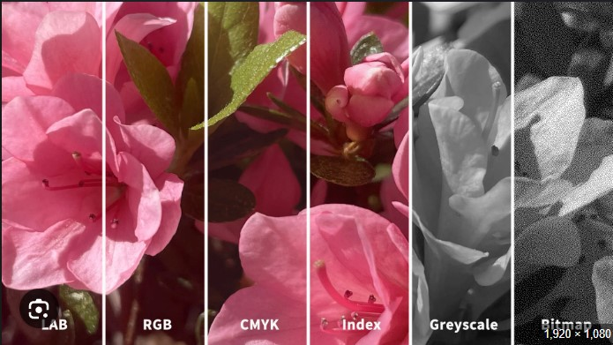

Image Formats:

* Raster Images: Consist of a grid of pixels (e.g., JPEG, PNG, GIF).
* Vector Images: Created using mathematical equations to produce lines and forms that retain their quality when enlarged (e.g., SVG).

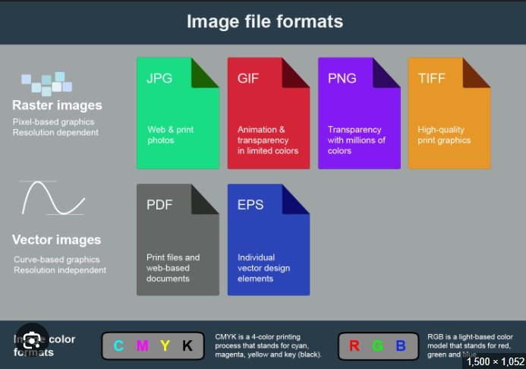

Image Processing Techniques:

* Filtering: Using techniques including blurring, sharpening, and edge detection to improve or analyze photographs.
* Segmentation: Dividing an image into segments to make analysis easier, such as detecting objects within the image.
* Transformation: Refers to geometric alterations such as rotation, scaling, and translation.

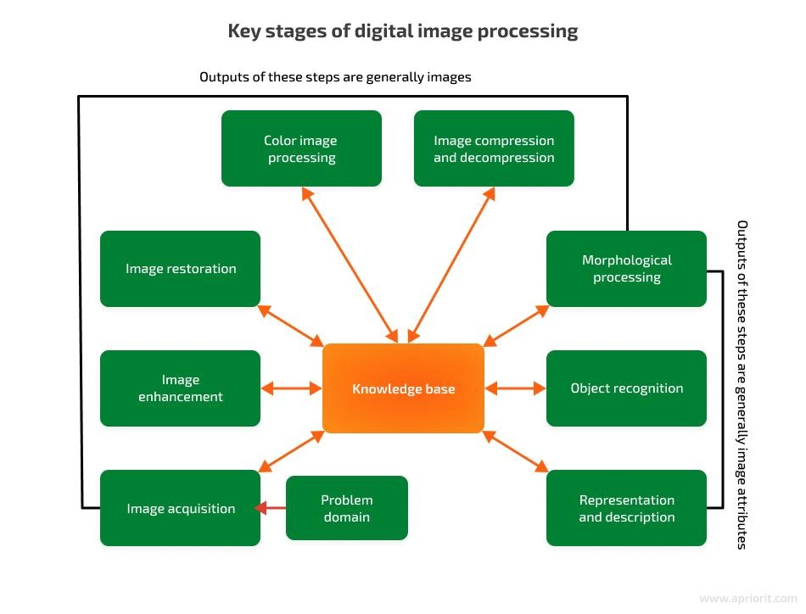

Histogram:

A graph representing the distribution of pixel intensity values in a picture.

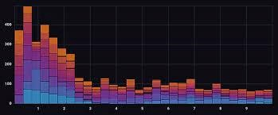

# 3D Data Visualization

3D Models:

* Meshes: Structures composed of vertices, edges, and faces that form 3D shapes.

Common file types are OBJ, STL, and PLY.

* Point Clouds: Sets of data points in space, usually created by 3D scanners.

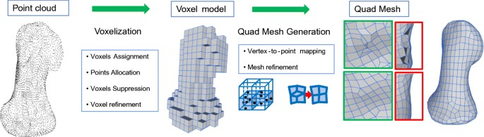

Coordinate System:

* Cartesian Coordinates: The most widely used system, which specifies positions using (x, y, z) coordinates.
* Polar and Spherical Coordinates: Alternative systems that can be useful in some situations.

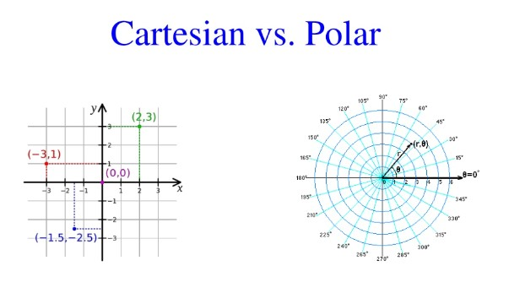

3D Transformation:

* Translation: The process of moving items in three dimensions.
* Rotation: The rotation of objects around a certain axis.
* Scaling: Changing the size of items.

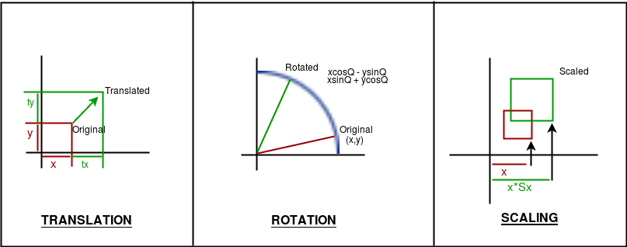

Viewing and Projections:

* Orthographic Projection: Projects objects without perspective distortion; size remains constant regardless of depth.
* Perspective Projection: Represents human vision in which items appear smaller as they move away from the viewer.

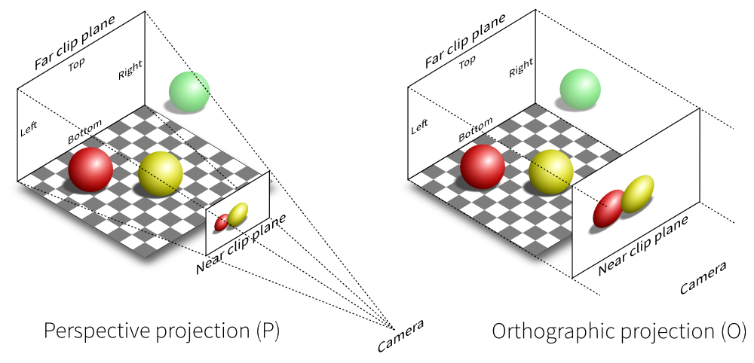

# Applications

Medical Imaging:

The three-dimensional visualization of complex data obtained from MRI or CT scans.

Scientific Visualization:

The process of representing data from simulations such as fluid dynamics or structural analysis.

Virtual Reality (VR) and Augmented Reality (AR):

Creating immersive experiences and superimposing digital information on the actual world.

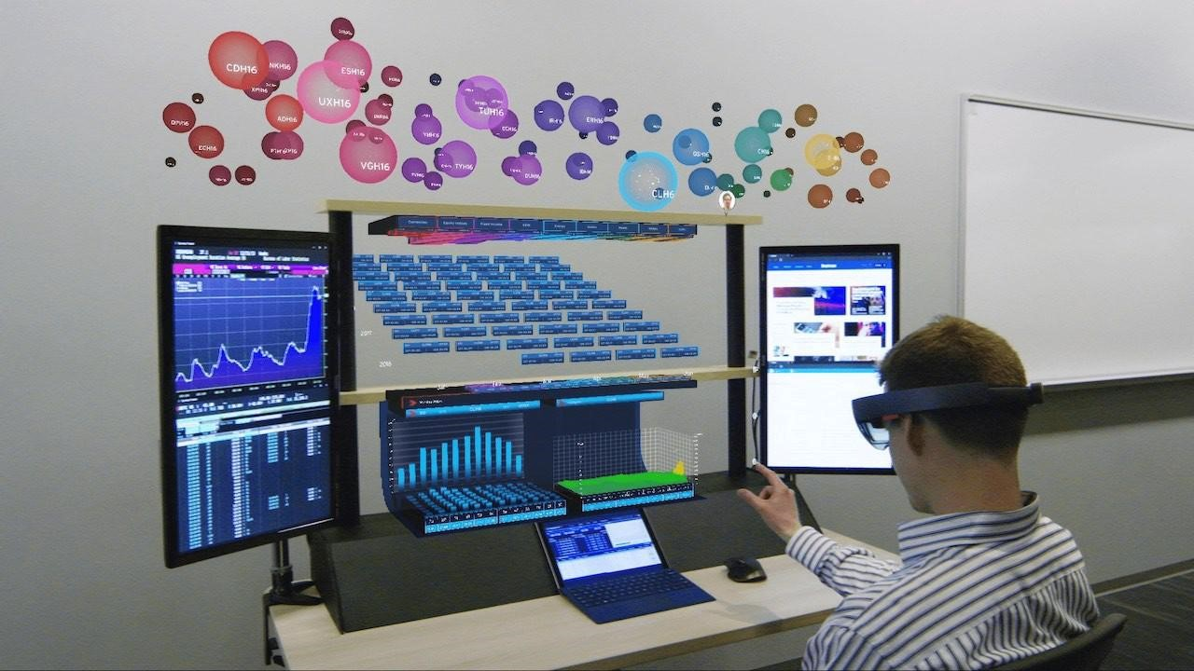

**IMAGE VISUALIZATION TECHNIQUES**

Visualization is a simple technique that you can use to create a strong mental image of a future event .It involves using all five senses of sight, smell, touch, taste, and hearing. The process of visualizing directs your subconscious to be aware of the end goal you have in mind.

Image visualization techniques are vital tools for interpreting and presenting visual data across various fields ,from medical imaging to computer graphics .These techniques enhance our ability to extract meaningful insights and make informed decisions.Image visulization techniques transform raw image data into understandable and interpretable visual formats. These methods range from simple 2D representations to complex 3D models and multimodal integrations, each serving specific purposed and application.

**BENEFITS OF USING VISUALIZATION TECHNIQUES**

The power of visualization is unparalleled. From neuroscientists to professional athletes and CEOs, all kinds of highly productive and fulfilled people credit these techniques as part of their success. 🏆

Here are some of the many benefits behind visualization techniques:

* **Clearer decision-making:**
* By creating a mental picture of your goals, you can make better decisions to reach them. You’ll be able to break down goals into smaller, achievable tasks and adapt to a changing environment
* **Improved mental health:**
* Visualization focuses on positive outcomes. This decreases anxiety, stress, and distractions so you can focus on what it takes to meet your goals
* **Increased confidence:**
* Seeing yourself in a successful situation builds your self-worth and makes the goals feel attainable
* **Healthier habits and behaviors:**
* By imagining what you want and how to get there, you lay the groundwork for better daily habits. That means more efficient work, prioritized efforts, and better evaluation of your progress

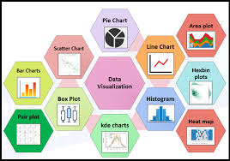

as if that outcome were true in the present moment.

There are two types of visualization:

**(1) outcome visualization:** [envisioning the desired future end-point](https://www.betterup.com/blog/career-planning), and

**(2) process visualization:**envisioning every step toward that desired outcome. With all the senses engaged.

When the two visualizations are used in tandem, they yield the best results.

### 2

### 2D IMAGE VISUALIZATION with visualization

2D image visualization techniques are essential tools for understanding and interpreting visual data presented in two dimensions. These methods play a crucial role in various fields such as medical imaging, remote sensing, computer vision, and data analysis. Here, we delve into some key 2D image visualization techniques and their applications:

Scatter Plots:Scatter plots are used to visualize the relationship between two variables. In image processing, scatter plots can reveal spatial relationships between pixels or interactions between different color channels. For example, in color image analysis, scatter plots of pixel intensities in different color spaces such as RGB, HSV, or LAB can help identify color correlations and anomalies.

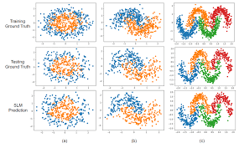 Histograms: Histograms are graphical representations of the distribution of pixel intensities within an image. By plotting pixel intensity values along the x-axis and their corresponding frequencies on the y-axis, histograms provide insights into the contrast and brightness of an image. In medical imaging, histograms are used to analyze tissue density variations in CT scans or to assess the distribution of pixel values in MRI images.

Heatmaps:Heatmaps use color gradients to represent data values within an image. They are particularly useful for visualizing feature intensities or activations. In fields like machine learning and computer vision, heatmaps are employed to visualize the importance of different image regions in deep learning models, aiding in tasks such as object detection, image segmentation, and attention mechanism visualization.

Contour Plots: Contour plots visualize three-dimensional data in a two-dimensional space using contour lines. These lines connect points of equal value, allowing for the visualization of intensity variations or elevation changes within an image. Contour plots are widely used in geographical mapping, meteorology, and image processing applications to represent topographic features, temperature gradients, and image intensity distributions.

False Color Imaging: False color imaging involves assigning colors to intensity values that are not visible to the naked eye. This technique enhances image detail and aids in visual interpretation. In satellite imagery, false color composites are used to highlight vegetation health, land use, and environmental changes. In medical imaging, false color representations of MRI or PET scans can improve the visualization of anatomical structures or metabolic activities.

**Applications:**

These 2D image visualization techniques find applications across various domains. In medical imaging, they aid in disease diagnosis, treatment planning, and surgical navigation. In remote sensing, they enable the analysis of environmental changes, land cover mapping, and disaster monitoring. In machine learning, they facilitate model interpretation, debugging, and performance evaluation. In data analysis, they support exploratory data analysis, pattern recognition, and anomaly detection.

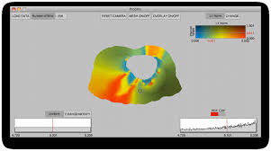

In conclusion, 2D image visualization techniques are indispensable tools for extracting insights and understanding complex visual data. They enable researchers, scientists, and practitioners to make informed decisions and derive actionable intelligence from images across diverse domains and applications.over how personalized coaching can guide you to visualize and achieve your dream goals effectively.

**3D IMAGE VISUALIZATION**

3D image visualization techniques are indispensable tools for comprehending and analyzing volumetric data in various fields such as medical imaging, scientific visualization, computer graphics, and engineering. These techniques provide valuable insights into spatial relationships, structural details, and volumetric properties, enhancing our understanding of complex three-dimensional structures. Here, we explore some key 3D image visualization techniques and their applications:

Volume Rendering: Volume rendering is a powerful technique used to visualize three-dimensional datasets in two dimensions. By rendering the volume data directly, it enables the visualization of internal structures and features, such as organs in medical imaging or fluid flow in computational fluid dynamics. Volume rendering algorithms, including ray casting and texture-based rendering, produce high-quality images that allow users to explore and analyze volumetric data from various perspectives.

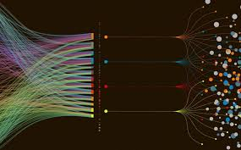

3D Surface Plots: 3D surface plots represent data in three dimensions using surfaces to visualize complex geometric structures or terrain. These plots are commonly used in computer-aided design (CAD), geographic information systems (GIS), and geological modeling to visualize topographic features, terrain elevations, and surface properties. By providing a three-dimensional representation of surfaces, they facilitate the analysis and interpretation of spatial data in diverse applications.

Isosurfaces: Isosurfaces are surfaces that represent constant values of a three-dimensional scalar field within a volumetric dataset. These surfaces are commonly used to visualize specific features or structures of interest, such as anatomical boundaries in medical imaging or fluid interfaces in computational fluid dynamics. Isosurface extraction algorithms, such as marching cubes or Marching Tetrahedra, enable the generation of detailed surface representations from volumetric data.

3D Scatter Plots: 3D scatter plots extend traditional scatter plots into three dimensions, allowing for the visualization of relationships between three variables. These plots are useful for exploring multidimensional datasets and identifying correlations or patterns within volumetric data. In fields such as data analysis, machine learning, and scientific visualization, 3D scatter plots provide valuable insights into the distribution and clustering of data points in three-dimensional space.

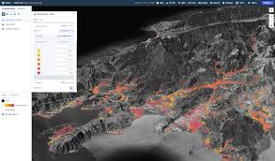

**Applications:**

These 3D image visualization techniques find applications across various domains. In medical imaging, they aid in the visualization of anatomical structures, tumor detection, and surgical planning. In scientific visualization, they enable the analysis of complex data from simulations, experiments, and numerical models. In computer graphics, they support the creation of immersive virtual environments, interactive simulations, and realistic visual effects. In engineering, they facilitate the design and analysis of mechanical components, architectural structures, and fluid flow systems.

In summary, 3D image visualization techniques are essential tools for exploring and understanding volumetric data in diverse fields. They enable researchers, scientists, and practitioners to visualize and analyze complex three-dimensional structures, leading to new discoveries, insights, and innovations across various domains and applications.

**MUTLI-MODAL IMAGE VISUALIZATION**

Multimodal image visualization techniques play a crucial role in integrating and interpreting data from different imaging modalities, such as magnetic resonance imaging (MRI), computed tomography (CT), positron emission tomography (PET), and functional MRI (fMRI). These techniques enable researchers and clinicians to combine information from multiple sources to gain a comprehensive understanding of anatomical structures, physiological functions, and pathological conditions. Here, we explore some key multimodal image visualization techniques and their applications:

Overlay Visualization: Overlay visualization involves combining multiple images by overlaying them, often using transparency to reveal information from different modalities. In medical imaging, overlay visualization allows clinicians to compare and correlate anatomical structures from MRI with functional information from PET or fMRI scans. This technique facilitates the localization of abnormalities, such as tumors or lesions, by providing complementary information from different imaging modalities.

Side-by-Side Comparison: Side-by-side comparison involves displaying images from different modalities next to each other for direct comparison. This technique enables researchers to visually assess differences or similarities between images acquired using different imaging techniques. In neuroscience research, side-by-side comparison of structural MRI and diffusion tensor imaging (DTI) data helps investigate the relationship between brain structure and connectivity, providing insights into brain organization and function.

Fusion Techniques: Fusion techniques combine data from different imaging modalities into a single coherent image, allowing for the integration of complementary information. In medical imaging, fusion techniques enable the visualization of anatomical structures alongside functional or molecular information, enhancing diagnostic accuracy and treatment planning. For example, fusion of MRI and PET data enables the precise localization of tumor boundaries and assessment of tumor metabolism, guiding therapeutic interventions in oncology.

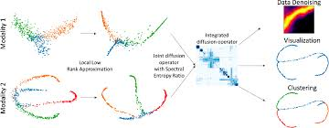

Interactive Visualization:Interactive visualization techniques allow users to interact with multimodal image data, facilitating exploration and analysis. Interactive tools enable users to adjust visualization parameters, such as opacity, color mapping, and image fusion, in real-time, enhancing the interpretability of multimodal images. In radiology, interactive visualization platforms enable radiologists to manipulate and navigate through multimodal image datasets, improving diagnostic confidence and efficiency.

**Applications:** Multimodal image visualization techniques find applications across various fields, including medical imaging, neuroscience, oncology, and biomedicine. In clinical practice, these techniques aid in disease diagnosis, treatment planning, and monitoring by providing comprehensive information from multiple imaging modalities. In research settings, multimodal image visualization techniques support the investigation of complex biological processes, disease mechanisms, and treatment responses, leading to advancements in our understanding of health and disease.

In summary, multimodal image visualization techniques play a crucial role in integrating and interpreting data from different imaging modalities, enabling comprehensive analysis and visualization of complex biological systems. These techniques provide valuable insights into anatomical, functional, and molecular information, contributing to advancements in medical diagnosis, research, and patient care.

**Introduction to 3D Data Visualization**

In the realm of data analysis and visualization, the ability to explore and understand three-dimensional (3D) data is essential for gaining insights into complex phenomena and spatial relationships. 3D data visualization techniques provide powerful tools for representing and interacting with multidimensional data in a visually intuitive manner.

Unlike traditional two-dimensional (2D) visualizations, which are limited to representing data in a flat plane, 3D data visualization allows us to visualize data in three-dimensional space, providing a more comprehensive view of the underlying information. This extra dimension enables us to explore spatial relationships, identify patterns, and uncover hidden insights that may not be apparent in 2D representations.

3D data visualization finds applications across a wide range of domains, including scientific research, engineering, medicine, geospatial analysis, and computer graphics. In scientific research, 3D visualization techniques are used to visualize complex datasets from disciplines such as astronomy, biology, and materials science, allowing researchers to analyze and interpret volumetric data, simulate physical phenomena, and explore spatial structures.

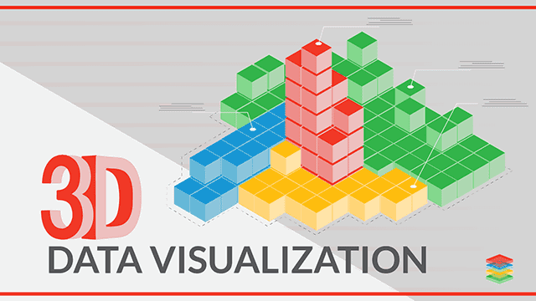

In engineering and design, 3D visualization plays a crucial role in modeling, simulation, and prototyping. Engineers and designers use 3D visualization techniques to visualize CAD models, simulate mechanical systems, and analyze fluid dynamics, enabling them to iteratively design and refine products with precision and accuracy.

In medicine, 3D visualization techniques are used to visualize medical imaging data from modalities such as computed tomography (CT), magnetic resonance imaging (MRI), and ultrasound. These techniques allow healthcare professionals to visualize internal anatomical structures, plan surgical procedures, and diagnose medical conditions with greater clarity and accuracy.

In geospatial analysis, 3D visualization techniques are used to visualize geographic data such as terrain models, urban landscapes, and environmental phenomena. Geospatial visualization enables researchers, planners, and policymakers to analyze spatial relationships, assess environmental impacts, and make informed decisions about land use and resource management.

Overall, 3D data visualization provides a powerful framework for exploring and understanding complex data in three-dimensional space. By leveraging advanced visualization techniques and technologies, researchers, engineers, and practitioners can unlock new insights, drive innovation, and make meaningful contributions to their respective fields.

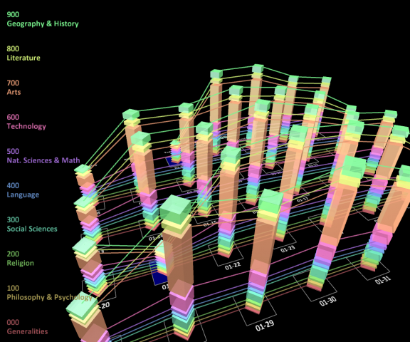

**Volumetric Rendering:** This technique is used to visualize volumetric data, such as medical imaging scans (CT, MRI), seismic data, or fluid dynamics simulations. It involves representing the data as a volume of voxels (3D pixels) and rendering them to produce a 3D image. Volumetric rendering techniques include ray casting, texture-based rendering, and direct volume rendering.

**Surface Rendering:** Surface rendering focuses on visualizing the external surfaces of three-dimensional objects or datasets. It involves creating a mesh or polygon representation of the surface and rendering it to produce a 3D image. Surface rendering techniques include polygonal rendering, isosurface extraction, and marching cubes algorithm.

**Multi-dimensional Scaling (MDS):** MDS is a dimensionality reduction technique used to visualize high-dimensional data in a lower-dimensional space while preserving the pairwise distances between data points. In 3D data visualization, MDS can be used to visualize complex datasets in a three-dimensional space, making it easier to interpret and explore relationships between data points.

**Introduction to Volumetric Rendering**

Volumetric rendering stands as a cornerstone in the realm of three-dimensional (3D) data visualization, offering a powerful technique for representing and exploring volumetric data in a visually intuitive manner. Unlike traditional surface rendering, which focuses on visualizing the external surfaces of objects or datasets, volumetric rendering enables us to visualize the internal structures and properties of volumetric data, such as medical imaging scans, scientific simulations, and engineering models.

At its core, volumetric rendering involves representing volumetric data as a three-dimensional grid of voxels (volumetric pixels), where each voxel contains information about the intensity, density, or other properties of the underlying data. By rendering these voxels in a coherent manner, volumetric rendering techniques create immersive visualizations that allow users to explore and analyze the internal composition of complex datasets.

One of the key advantages of volumetric rendering is its ability to provide insights into spatial relationships and structures within volumetric data. For example, in medical imaging, volumetric rendering techniques enable healthcare professionals to visualize internal anatomical structures, such as organs, tissues, and blood vessels, with high fidelity and detail. This capability is invaluable for tasks such as diagnosing medical conditions, planning surgical procedures, and monitoring disease progression.

Moreover, in computer graphics and entertainment, volumetric rendering techniques are used to create realistic and immersive visual effects in movies, video games, and virtual reality experiences. By simulating the interaction of light with volumetric materials and environments, volumetric rendering enables artists and designers to create stunning visualizations that captivate audiences and enhance storytelling.

In summary, volumetric rendering is a versatile and powerful technique for visualizing volumetric data in three-dimensional space. By providing insights into internal structures and properties, volumetric rendering enables us to explore and understand complex datasets in fields ranging from medicine and science to computer graphics and entertainment. As we continue to push the boundaries of what's possible in volumetric rendering, we unlock new opportunities for innovation, discovery, and creativity in the visualization of volumetric data.

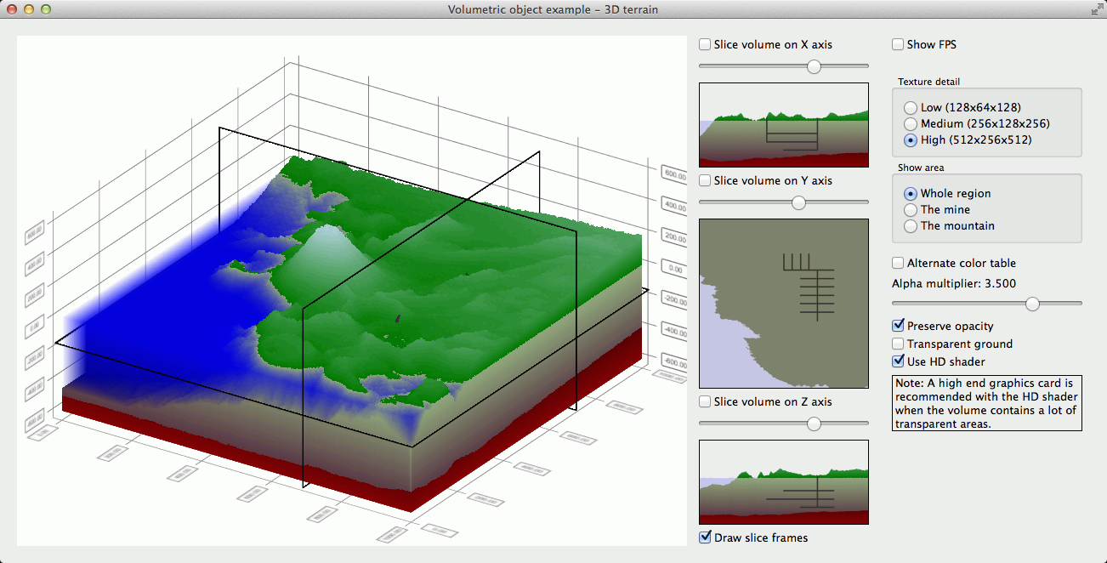

**Introduction to Surface Rendering**

Surface rendering stands as a fundamental technique in the field of three-dimensional (3D) data visualization, offering a powerful method for representing and exploring the external surfaces of objects or datasets in a visually compelling manner. Unlike volumetric rendering, which focuses on visualizing the internal structures of volumetric data, surface rendering enables us to visualize the external boundaries and features of objects or datasets, providing insights into their shape, form, and composition.

At its core, surface rendering involves creating a mesh or polygonal representation of the surface geometry from the underlying 3D data and rendering it to produce a realistic or stylized representation of the surface. This mesh consists of interconnected vertices, edges, and faces that define the surface topology and geometry, allowing us to visualize complex shapes and structures with precision and detail.

One of the key advantages of surface rendering is its ability to provide a clear and intuitive representation of surface features and structures within 3D datasets. For example, in scientific visualization, surface rendering techniques enable researchers to visualize molecular structures, geological formations, and anatomical surfaces with high fidelity and detail. This capability is invaluable for tasks such as studying molecular interactions, analyzing terrain features, and visualizing biological structures.

In engineering and design, surface rendering techniques are used to visualize CAD models, mechanical assemblies, and architectural designs, enabling engineers and designers to visualize product prototypes, analyze surface features, and assess design aesthetics. By visualizing surface geometry and material properties, surface rendering facilitates the iterative design process and enables rapid prototyping and validation of designs.

Moreover, in computer graphics and entertainment, surface rendering techniques are used to create realistic and immersive visual effects in movies, video games, and virtual reality experiences. By simulating the interaction of light with surface materials and environments, surface rendering enables artists and designers to create stunning visualizations that captivate audiences and enhance storytelling.

In summary, surface rendering is a versatile and essential technique for visualizing surface geometry and features within 3D datasets. By providing insights into surface shape, form, and composition, surface rendering enables us to explore and understand complex objects and structures in fields ranging from science and engineering to computer graphics and entertainment. As we continue to push the boundaries of what's possible in surface rendering, we unlock new opportunities for innovation, discovery, and creativity in the visualization of 3D data.

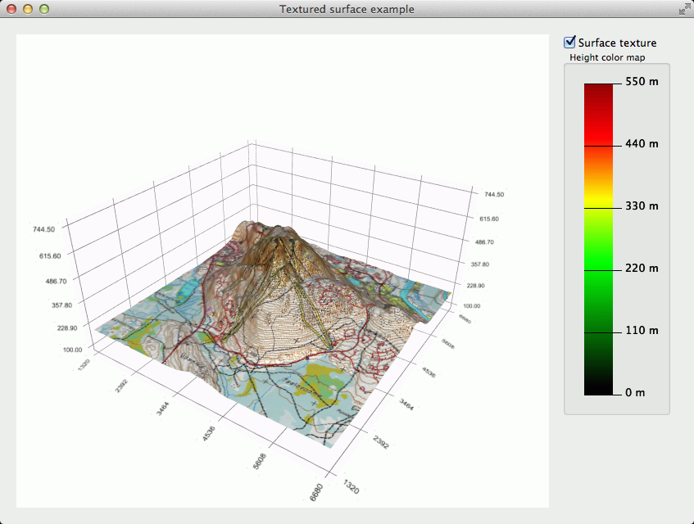

**Introduction to Multi-dimensional Scaling (MDS)**

Multi-dimensional scaling (MDS) is a powerful dimensionality reduction technique used in data visualization to represent high-dimensional data in a lower-dimensional space while preserving the pairwise distances or dissimilarities between data points as much as possible. MDS is particularly useful for visualizing and exploring complex datasets where the relationships between data points are not immediately apparent.

At its core, MDS seeks to find a low-dimensional representation of the data that best preserves the similarities or dissimilarities between data points. This is achieved by projecting the data onto a lower-dimensional space, typically two or three dimensions for visualization purposes, while minimizing the discrepancy between the original pairwise distances and the distances in the reduced-dimensional space.

One of the key advantages of MDS is its ability to reveal underlying patterns and structures within high-dimensional data that may not be apparent in the original data space. By visualizing the data in a lower-dimensional space, MDS enables researchers and practitioners to explore relationships, clusters, and trends within the data, facilitating insights and hypothesis generation.

There are two main types of MDS: metric MDS and non-metric MDS. Metric MDS aims to preserve the actual distances between data points in the reduced-dimensional space, while non-metric MDS focuses on preserving the rank order of distances or dissimilarities between data points. Both types of MDS have their own advantages and applications, depending on the nature of the data and the specific goals of the analysis.

MDS finds applications in various fields, including psychology, sociology, biology, marketing, and computer vision, where it is used for tasks such as visualizing similarity structures, clustering data points, and dimensionality reduction for further analysis. In psychology and sociology, MDS is often used to visualize and interpret similarity judgments or preference data. In biology, MDS is used to visualize genetic relationships or phylogenetic trees. In marketing, MDS is used to analyze consumer preferences and market segmentation.

In summary, multi-dimensional scaling (MDS) is a versatile and powerful technique for visualizing and exploring high-dimensional data. By projecting the data onto a lower-dimensional space while preserving the underlying relationships between data points, MDS enables researchers and practitioners to gain insights into complex datasets and uncover hidden patterns and structures. As we continue to push the boundaries of what's possible in data visualization, MDS remains a valuable tool for understanding and interpreting multidimensional data.

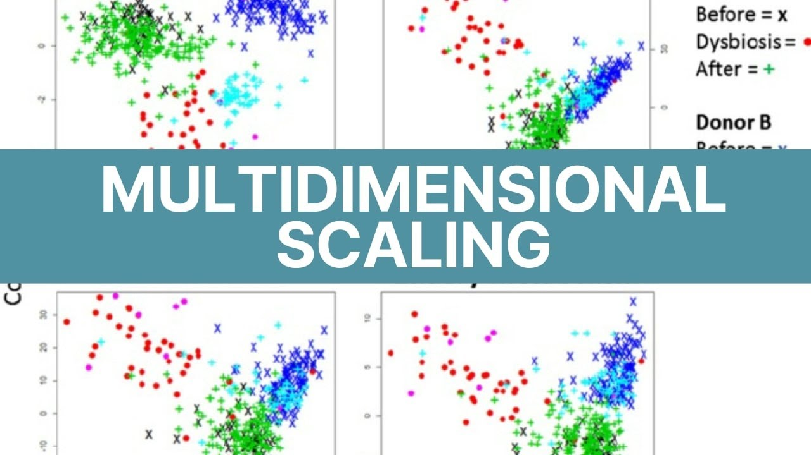

**Visualization Libraries for Images and 3D Data:**

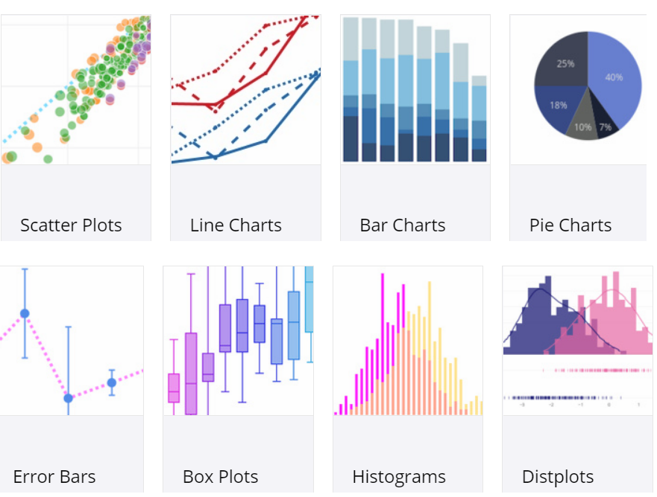

**Matplotlib:**

Matplotlib is a versatile and widely-used plotting library in Python that is suitable for a variety of visualization tasks, including both 2D and basic 3D data visualizations. Here’s an overview of Matplotlib and its capabilities:

**Overview of Matplotlib**

* **Core Components**:
  + **pyplot**: A collection of functions that make Matplotlib work like MATLAB, providing a convenient interface for creating plots.
  + **Artist**: Everything you see on a plot (e.g., lines, text, markers) is an artist object

**Key Features**

1. **2D Plotting**
   * **Basic Plots**: Line plots, scatter plots, bar charts, histograms, pie charts, etc.
   * **Customization**: Colors, labels, annotations, titles, axes labels, gridlines.
   * **Subplots**: Creating multiple plots in a single figure using **subplots()**.
2. **3D Plotting**
   * **mpl_toolkits.mplot3d**: A module in Matplotlib for 3D plotting.
   * **3D Plot Types**:
     + **3D Scatter Plots**: **ax.scatter()**.
     + **3D Line Plots**: **ax.plot()**.
     + **3D Surface Plots**: **ax.plot_surface()**.
     + **3D Wireframe Plots**: **ax.plot_wireframe()**.
3. **Image Visualization**
   * **imshow()**: Displaying images with Matplotlib.
   * **Customization**: Colormaps, interpolation, aspect ratios.
4. **Interactivity**
   * **Widgets**: Sliders, buttons, checkboxes for interactive plots.
   * **Animations**: Creating animated plots using **FuncAnimation**.
5. **Integration**
   * **Pandas**: Easy integration with data frames for plotting.
   * **NumPy**: Efficient handling of arrays and mathematical functions.

**Basic 2D Plot:**

**Code:**

import matplotlib.pyplot as plt

x = [1, 2, 3, 4, 5]

y = [2, 3, 5, 7, 11]

plt.plot(x, y, marker='o')

plt.title("Simple Line Plot")

plt.xlabel("X-axis")

plt.ylabel("Y-axis")

plt.grid(True)

plt.show()

**output:**

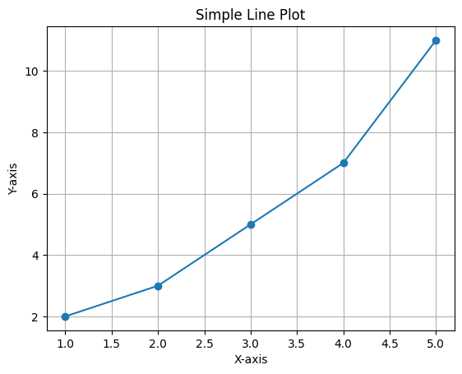

**3D Scatter Plot:**

**Code:**

import matplotlib.pyplot as plt

from mpl_toolkits.mplot3d import Axes3D

fig = plt.figure()

ax = fig.add_subplot(111, projection='3d')

x = [1, 2, 3, 4, 5]

y = [2, 3, 5, 7, 11]

z = [5, 6, 2, 3, 13]

ax.scatter(x, y, z)

ax.set_title("3D Scatter Plot")

ax.set_xlabel("X-axis")

ax.set_ylabel("Y-axis")

ax.set_zlabel("Z-axis")

plt.show()

**output:**

Matplotlib is an essential tool for data visualization in Python, offering extensive capabilities for both 2D and 3D plotting. Its integration with other scientific libraries like NumPy and Pandas makes it particularly powerful for scientific computing and data analysis. While it is very customizable, it also has a steep learning curve, but its comprehensive documentation and large community support make it accessible for both beginners and advanced users.

**Seaborn:**

Seaborn is a powerful Python data visualization library based on Matplotlib, designed to make it easier to create informative and attractive statistical graphics. It provides a high-level interface for drawing attractive and informative statistical graphics, making it ideal for exploring and understanding your data .Seaborn, primarily known for its powerful statistical visualizations, is not designed for direct image visualization or 3D data visualization. However, Seaborn can complement these tasks by providing statistical context and enhancing visualizations with its high-level plotting capabilities. For direct image and 3D data visualizations, we typically rely on other specialized libraries, but they can be combined with Seaborn to create more informative visualizations.

**Overview of Seaborn**

* **Description**: Seaborn is built on top of Matplotlib and is closely integrated with Pandas data structures. It simplifies the process of creating complex plots and visualizations with less code and more aesthetic appeal.
* **Core Components**: Seaborn focuses on the following key areas:
  + **Themes**: Provides aesthetic themes and color palettes to make plots visually appealing.
  + **Statistical Plots**: Offers functions to create common statistical plots with ease.
  + **Integration**: Works seamlessly with Pandas data structures.

**Key Features**

1. **Themes and Color Palettes**
   * **Themes**: **set_style()**, **set_context()**
   * **Color Palettes**: **color_palette()**, **set_pa**
2. **Statistical Plots**
   * **Relational Plots**:
     1. **scatterplot()**: Plots scatter plots.
     2. **lineplot()**: Plots line charts.
     3. **relplot()**: Combines scatter and line plots with additional facets.
   * **Categorical Plots**:
     1. **stripplot()**: Plots categorical scatter plots.
     2. **swarmplot()**: Plots categorical scatter plots with non-overlapping points.
     3. **boxplot()**: Plots box plots.
     4. **violinplot()**: Plots violin plots.
     5. **barplot()**: Plots bar charts.
     6. **pointplot()**: Plots point plots.
     7. **catplot()**: Combines all categorical plots with additional facets.
   * **Distribution Plots**:
     1. **histplot()**: Plots histograms.
     2. **kdeplot()**: Plots kernel density estimates.
     3. **distplot()**: Plots univariate distributions.
     4. **jointplot()**: Plots joint distributions with marginal histograms.
     5. **pairplot()**: Plots pairwise relationships in a dataset.
   * **Matrix Plots**:
     1. **heatmap()**: Plots heatmaps.
     2. **clustermap()**: Plots clustered heatmaps.
3. **Faceting and Multi-Plot Grids**
   * **FacetGrid**: Creates grids of subplots based on the values of a variable.
   * **PairGrid**: Creates a matrix of subplots to visualize pairwise relationships.

**Example:**

**Code:**

import matplotlib.pyplot as plt

from mpl_toolkits.mplot3d import Axes3D

import seaborn as sns

import numpy as np

# Generate random 3D data

x = np.random.random(100)

y = np.random.random(100)

z = np.random.random(100)

# Create a 3D scatter plot

fig = plt.figure()

ax = fig.add_subplot(111, projection='3d')

ax.scatter(x, y, z, c='b', marker='o')

ax.set_title("3D Scatter Plot")

ax.set_xlabel("X-axis")

ax.set_ylabel("Y-axis")

ax.set_zlabel("Z-axis")

plt.show()

# Using Seaborn to create related 2D plots

sns.scatterplot(x=x, y=y)

plt.title("2D and 3D Data (X vs Y)")

plt.show()

sns.kdeplot(x=x, y=z, fill=True)

plt.title("Kernel Density Estimate of X and Z")

plt.show()

**output:**

**PLOTLY:**

Plotly is a powerful Python library used for creating interactive visualizations for data analysis and presentation. It offers a wide range of chart types, from basic line plots to complex 3D plots and maps. Here's a brief overview of the features and capabilities of Plotly:

In the vast landscape of data visualization tools, Plotly stands tall as a beacon of innovation and utility. From its inception, Plotly has captivated data enthusiasts with its dynamic capabilities, empowering users to transform raw datasets into compelling visual narratives. In this comprehensive introduction, we embark on a journey through the rich ecosystem of Plotly, exploring its multifaceted features, interactive prowess, and transformative impact on data exploration and analysis.

**Overview of Plotly**

* **Description**: Plotly is a leading data visualization library renowned for its versatility, interactivity, and ease of use. Designed for Python, R, and JavaScript, Plotly empowers users to create dynamic, interactive visualizations that facilitate insights discovery, exploration, and presentation..
* **Core Components**:
  + **Figure**: The Figure object is the core component of Plotly visualizations. It represents the entire plot and contains all the other components such as traces, layout, and annotations.
  + **Traces**: Traces are the individual data series or datasets plotted on the graph. Each trace corresponds to a specific type of visualization, such as a scatter plot, line plot, bar chart, or heatmap.
    - **Key Features**

1. **2D Plotting**
   * **Basic Plots**: Line plots, scatter plots, bar charts, histograms, pie charts, etc.
   * **Customization**: Colors, labels, annotations, titles, axes labels, gridlines.
   * **Subplots**: Creating multiple plots in a single figure using **subplots()**.
2. **3D Plotting**
   * **mpl_toolkits.mplot3d**: A module in Matplotlib for 3D plotting.
   * **3D Plot Types**:
     + **3D Scatter Plots**: **ax.scatter()**.
     + **3D Line Plots**: **ax.plot()**.
     + **3D Surface Plots**: **ax.plot_surface()**.
     + **3D Wireframe Plots**: **ax.plot_wireframe()**.
3. **Image Visualization**
   * **go.Scatter:** to 'lines+markers' to plot both lines and markers..
   * **go.Layout**: specifying the plot title and axis labels.
4. **Interactivity**
   * **Widgets**: Sliders, buttons, checkboxes for interactive plots.
   * **Animations**: Creating animated plots using **FuncAnimation**.
5. **Integration**
   * **Pandas**: Easy integration with data frames for plotting.
   * **NumPy**: Efficient handling of arrays and mathematical functions.

**Basic 2D Plot:**

**Code:**

import plotly.graph_objs as go

# Sample data

x_data = [1, 2, 3, 4, 5]

y_data = [2, 3, 5, 7, 11]

# Create a trace

trace = go.Scatter(

x=x_data,

y=y_data,

mode='lines+markers', # Plot both lines and markers

name='Sample Data'

)

# Create layout

layout = go.Layout(

title='Sample 2D Plot', # Plot title

xaxis=dict(title='X-axis'), # X-axis label

yaxis=dict(title='Y-axis') # Y-axis label

)

# Create a figure

fig = go.Figure(data=[trace], layout=layout)

# Display the plot

fig.show()

**output:** 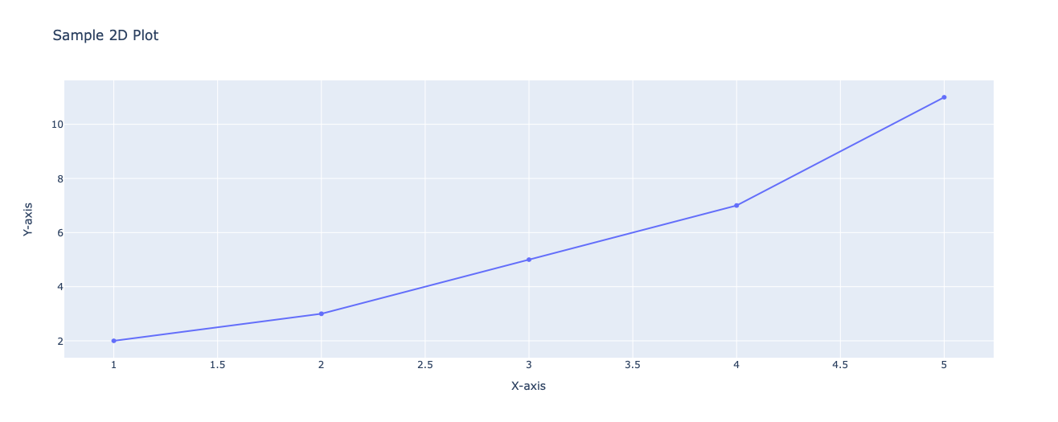

**3D Scatter Plot:**

**Code:**

import plotly.graph_objs as go

# Sample data

x_data = [1, 2, 3, 4, 5]

y_data = [2, 3, 5, 7, 11]

z_data = [1, 4, 9, 16, 25]

# Create a trace

trace = go.Scatter3d(

x=x_data,

y=y_data,

z=z_data,

mode='markers', # Plot markers only

marker=dict(

size=10, # Marker size

color=z_data, # Color based on z-value

colorscale='Viridis', # Color scale

opacity=0.8 # Marker opacity

),

name='Sample Data'

)

# Create layout

layout = go.Layout(

title='Sample 3D Plot', # Plot title

scene=dict(

xaxis=dict(title='X-axis'), # X-axis label

yaxis=dict(title='Y-axis'), # Y-axis label

zaxis=dict(title='Z-axis') # Z-axis label

)

)

# Create a figure

fig = go.Figure(data=[trace], layout=layout)

# Display the plot

fig.show()

**output:**

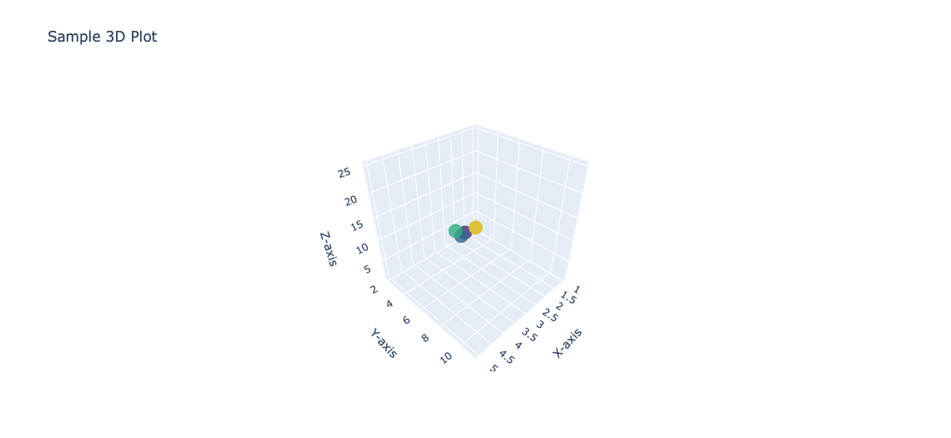

The library's seamless integration with Python, R, and JavaScript environments ensures compatibility with a wide range of workflows, while its interactive capabilities enable users to delve deeper into their data and uncover hidden patterns and trends.

In conclusion, Plotly stands as a formidable tool for data visualization, offering a versatile platform for creating interactive and visually engaging plots. Whether you're exploring data, presenting insights, or building web applications, Plotly provides a comprehensive suite of features to meet your needs.

With its intuitive interface and extensive customization options, Plotly empowers users to transform raw data into insightful visualizations that facilitate understanding and decision-making.

**BOKEH:**

In the dynamic realm of data visualization, where insights are sought and stories are told, Bokeh emerges as a powerful ally. Bokeh, a Python library, stands at the forefront of interactive visualization tools, empowering users to craft captivating visual narratives that breathe life into their data. In this introduction, we embark on a journey to explore the transformative capabilities of Bokeh, from its intuitive interface to its dynamic interactive features. Bokeh, pronounced as "BOH-kay," is an open-source library that provides elegant and concise tools for creating interactive plots, dashboards, and applications in Python. Developed by the Data Science team at Anaconda, Bokeh is designed to simplify the process of building interactive visualizations while maintaining flexibility and performance.

**Overview of Bokeh:**

* **Description**: Bokeh is a powerful Python library for creating interactive and visually appealing data visualizations. Developed by Anaconda Inc., Bokeh is designed to simplify the process of building interactive plots, dashboards, and applications, enabling users to communicate insights effectively and engage audiences with their data.
* **Core Components**: Bokeh focuses on the following key areas:
  + **Plot**: The Plot object is the central component of Bokeh visualizations. It represents the entire plot and contains all the other components such as glyphs, tools,.
  + **Glyphs**: Glyphs are the visual elements that represent data on the plot, such as points, lines, bars, and patches.
  + **Data Sources**: Data sources contain the actual data that is displayed on the plot. Bokeh supports various data formats, including NumPy arrays, Pandas DataFrames, and Python lists..

**Key Features**

1. **Interactive Visualization**
   * **Interactive Visualization**: Bokeh provides powerful tools for creating interactive visualizations that allow users to explore data dynamically.
2. **Versatile Plot Types**
   * **versatile Plot Types**: Bokeh supports a wide range of plot types, including line plots, scatter plots, bar charts, histograms, heatmaps, and more.
3. **Web-Based Deployment**
   * **Web-Based Deployment**: Bokeh enables users to deploy interactive visualizations as standalone web applications or embed them within web pages

**Example:**

**Code:**

from bokeh.plotting import figure, output_notebook, show

# Sample data

x_data = [1, 2, 3, 4, 5]

y_data = [2, 3, 5, 7, 11]

# Create a new plot with a title and axis labels

p = figure(title='Simple Line Plot', x_axis_label='X-axis', y_axis_label='Y-axis')

# Add a line renderer with circle markers

p.line(x_data, y_data, line_width=2, legend_label='Line Plot')

p.circle(x_data, y_data, fill_color='white', size=8)

# Display the plot inline in the notebook

output_notebook()

# Show the plot

show(p)

**output:** 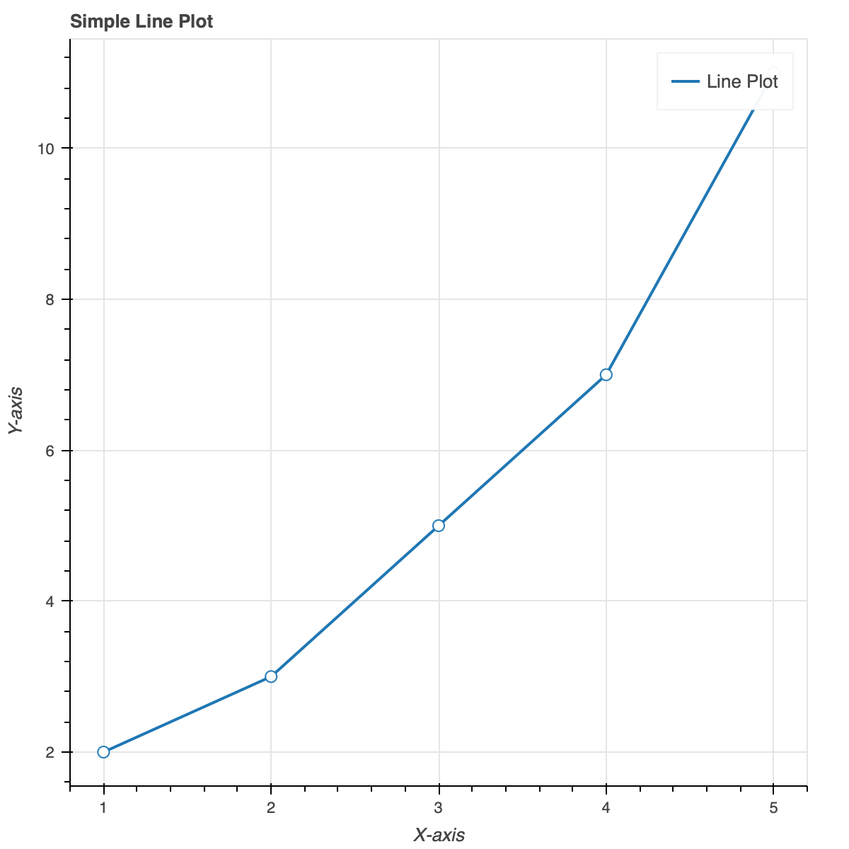

**VisPY:**

In t VisPy is an open-source Python library that provides high-performance, GPU-accelerated visualization capabilities for scientific data and 3D graphics. Developed as a collaboration between academic and industry researchers, VisPy leverages modern graphics hardware to deliver fast and interactive visualizations for a wide range of applications.

VisPy is designed to address the growing demand for high-performance visualization tools in scientific computing, data analysis, and 3D graphics applications. By harnessing the computational power of modern graphics processing units (GPUs), VisPy enables users to create visually stunning and interactive visualizations with ease.

n the realm of scientific computing, data analysis, and 3D graphics, VisPy emerges as a cutting-edge Python library revolutionizing the way visualizations are created and interacted with. By harnessing the computational prowess of modern GPUs, VisPy offers unparalleled performance and flexibility, empowering users to visualize complex datasets and simulations with stunning clarity and interactivity.

**Overview of VisPy:**

* **Description**: VisPy is a Python library designed to provide high-performance, GPU-accelerated visualization capabilities for scientific data, simulations, and 3D graphics. Developed as an open-source project, VisPy leverages the computational power of modern graphics hardware to deliver fast and interactive visualizations with stunning clarity and detail.
* **Core Components**: VisPy focuses on the following key areas:
  + **Canvas**: The Canvas is the main drawing surface where visualizations are rendered. It serves as the container for all visual elements, including primitives, meshes, and textures.
  + **Visuals**: Visuals are the graphical elements that represent data or objects in the visualization. They include primitives such as points, lines, and polygons, as well as more complex shapes and meshes.
  + **Scene**: The Scene is a hierarchical structure that organizes visual elements in the Canvas. It allows users to group visuals together, apply transformations, and control their visibility and rendering order.

**Key Features**

1. **GPU Acceleration**
   * **GPU Acceleration**: VisPy harnesses the parallel processing capabilities of modern graphics processing units (GPUs) to accelerate rendering.

**2.** **High-Quality Graphics**

1. **High-Quality Graphics**: VisPy supports advanced rendering techniques, including shaders, textures, and lighting effects, to create visually stunning graphics with high fidelity and realism.

3. **Interactivity**:

1. **Interactivity**: With its GPU-accelerated rendering engine, VisPy provides smooth and responsive interaction with visualizations, allowing users to manipulate views, explore datasets, and navigate 3D scenes in real-time.

**Example:**

**Code:**

import numpy as np

from vispy import app, gloo

from vispy.scene import SceneCanvas

from vispy.visuals import Line

# Create vertex and fragment shaders

vertex = """

attribute vec2 a_position;

void main (void) {

gl_Position = vec4(a_position, 0.0, 1.0);

}

"""

fragment = """

void main()

{

gl_FragColor = vec4(1.0, 0.0, 0.0, 1.0);

}

"""

# Create a simple scene with a line

canvas = SceneCanvas(keys='interactive', show=True)

view = canvas.central_widget.add_view()

line = Line(pos=np.array([[0, 0], [0.5, 1.0]]), color='blue', width=5.0, parent=view.scene)

# Run the application

app.run()

**output:**

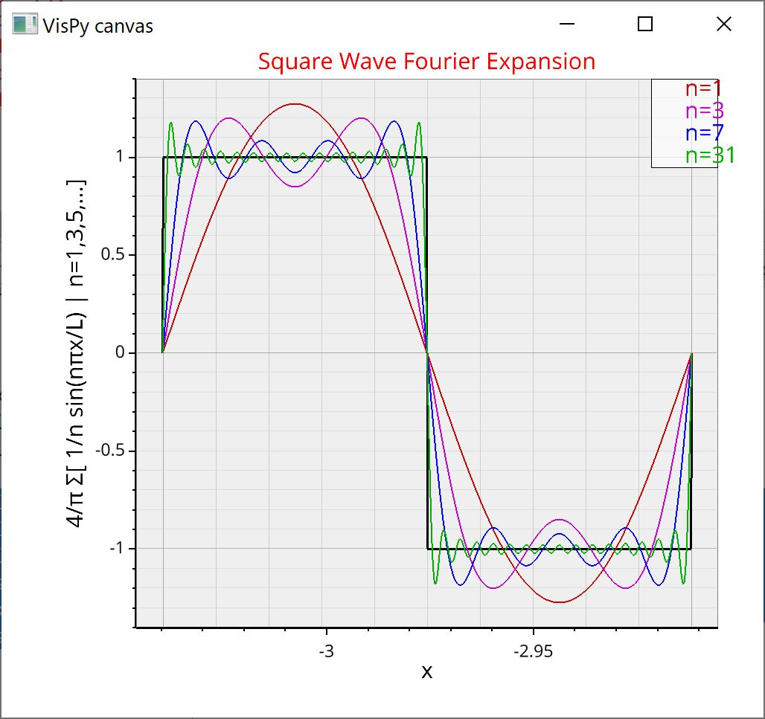

**Best practices for visualizing Images and 3D Data:**

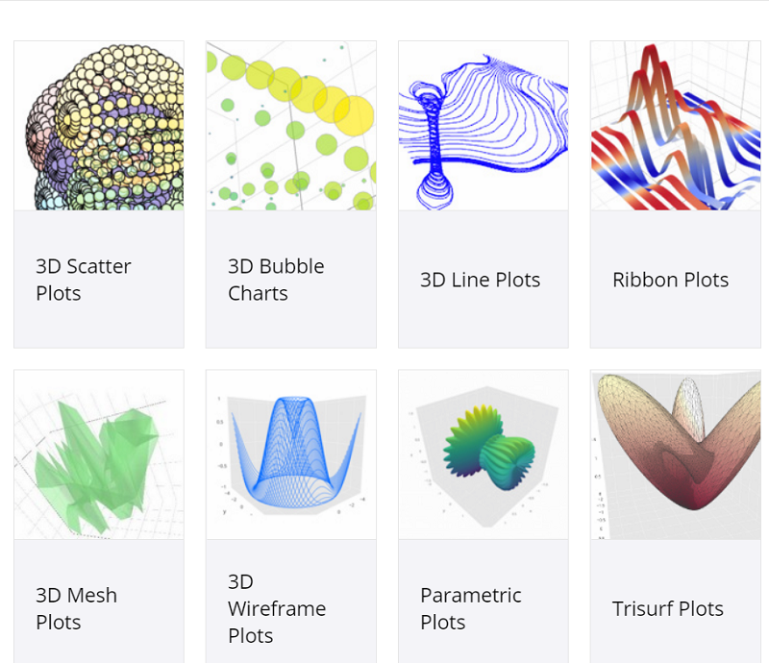

1. Understand Your Data: Is the foundational step in any data visualization process. It involves a comprehensive examination and analysis of the data you are working with to ensure that the visualizations you create are accurate, meaningful, and effective. Here is an in-depth explanation of what it entails:

1.1 Data Types and Formats:

* Identify Data Types: Determine whether your data consists of images (2D), 3D models, volumetric data, or a combination.
* Data Formats: Understand the formats of your data (e.g., JPEG, PNG for images; OBJ, STL for 3D models; DICOM for medical imaging).

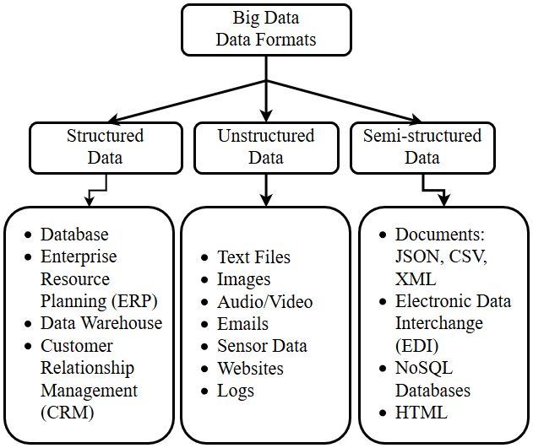

1.2 Data Characteristics:

* Resolution: Know the resolution of your images and 3D models, as higher resolution can provide more detail but also requires more processing power.
* Dimensions: Be aware of the spatial dimensions of your data. For 3D models, this includes width, height, and depth.

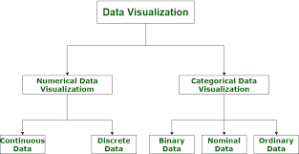

1.3 Data Acquisition:

* Source: Understand where and how the data was acquired. This could include methods such as scanning, photography, remote sensing, or simulations.
* Conditions: Know the conditions under which the data was collected, as this can affect its quality and relevance.

1.4 Data Integrity and Quality:

* Accuracy: Assess the accuracy of your data. Ensure that the data correctly represents the real-world scenario or theoretical model.
* Completeness: Check for any missing or incomplete data points.
* Noise and Artifacts: Identify and understand the presence of noise or artifacts that might need to be cleaned or corrected.

1.5 Data Preprocessing:

* Cleaning: Remove any noise, outliers, or irrelevant information from your data to improve the clarity and quality of your visualizations.
* Normalization: Normalize the data values to a common scale if necessary, to ensure consistency in visual representation.

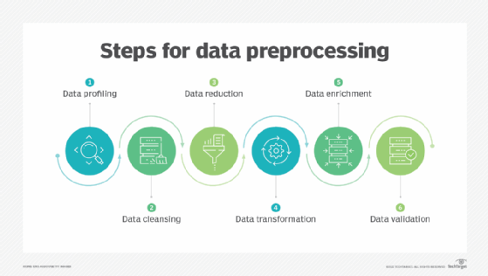

1.6 Data Structure and Relationships:

* Hierarchical Structure: Understand if your data has a hierarchical structure (e.g., anatomical structures in medical imaging).
* Spatial Relationships: Recognize the spatial relationships between different elements in your data, such as proximity, overlap, and connectivity.
* Context and Metadata:
* Contextual Information: Gather contextual information that can help interpret the data, such as labels, annotations, and reference scales.
* Metadata: Review the metadata associated with your data, including acquisition parameters, timestamps, and sensor information.

1.7 Data Variability and Range:

* Dynamic Range: Assess the dynamic range of your data to ensure that your visualization can capture the full extent of data variations.
* Variability: Understand the variability within your data, such as changes over time or differences between datasets.

1.8 Data Segmentation:

* Regions of Interest: Identify regions or features of interest within your data that you may want to focus on in your visualization.
* Segmentation Techniques: Apply appropriate segmentation techniques to isolate these regions for more detailed analysis.

1.9 Ethical Considerations:

* Privacy and Confidentiality: Ensure that any personal or sensitive data is handled in accordance with ethical guidelines and privacy laws.
* Bias and Representation: Be aware of potential biases in your data and strive to represent it accurately and fairly.
* Understanding your data thoroughly allows you to make informed decisions about how to visualize it effectively. It helps in choosing the right visualization techniques, tools, and methods, and ensures that the visualizations provide accurate, meaningful insights to the audience.

2. Choosing appropriate tools: is essential for effective visualization of images and 3D data. The right tools help ensure that visualizations are accurate, intuitive, and useful for analysis. Here’s a comprehensive guide to choosing the appropriate tools in view of best practices for visualizing images and 3D data:

2.1 Identify the Type of Data:

* 2D Images: Use tools that specialize in image processing and analysis, such as Adobe Photoshop, GIMP, ImageJ, or MATLAB.
* 3D Models: For 3D data, consider software like Blender, Autodesk Maya, Unity, and SketchUp.
* Volumetric Data: Tools like Para View, 3D Slicer, and Amira are well-suited for handling volumetric data common in scientific and medical fields.

2.2 Consider the Visualization Requirements:

* Interactivity: If interactive visualizations are required, choose tools like plotly, D3.js, or Three.js, which allow for dynamic and interactive visual elements.
* High-Quality Rendering: For high-quality and photorealistic rendering, tools like Blender, Autodesk Maya, and V-Ray are excellent choices.
* Scalability: For large datasets, consider scalable visualization tools such as Para View, which can handle extensive data without compromising performance.

2.3 Evaluate the Features of the Tools:

* Ease of Use: Tools with user-friendly interfaces and extensive documentation, such as MATLAB and ImageJ, are beneficial for beginners.
* Customization: Tools like Python with libraries such as Matplotlib, Seaborn, and Mayavi offer extensive customization options for more advanced users.
* Support for Multiple Formats: Ensure the tool supports various data formats. For example, Para View supports VTK, PLY, STL, and OBJ formats, making it versatile for different types of 3D data.

2.4 Performance and Optimization:

* Hardware Requirements: Choose tools that match your hardware capabilities. High-end tools like Autodesk Maya may require powerful GPUs, whereas ImageJ can run efficiently on standard desktop computers.
* Processing Speed: For real-time processing and visualization, tools like Unity and Unreal Engine are optimized for speed and performance.

2.5 Integration Capabilities:

* Interoperability: Tools that can easily integrate with other software or libraries are beneficial. For instance, MATLAB can integrate with Python and C++ for extended functionality.
* Workflow Integration: Ensure the tool fits well within your existing workflow. For example, 3D Slicer is ideal for medical imaging workflows due to its extensive medical image processing capabilities.

2.6 Community and Support:

* Community Support: A large user community can be a valuable resource for troubleshooting and finding tutorials. Tools like Blender and Unity have active user forums and communities.
* Documentation and Tutorials: Comprehensive documentation and availability of tutorials can significantly ease the learning curve. Tools like Plotly and Matplotlib have extensive online resources and tutorials.

2.7 Cost and Licensing:

* Open Source vs. Commercial: Open-source tools like Blender and GIMP are free and highly customizable, whereas commercial tools like Adobe Photoshop and Autodesk Maya offer advanced features and professional support but at a cost.
* Licensing Flexibility: Consider the licensing terms and whether they align with your project needs, especially for commercial use or academic research.

3. High resolution: is a crucial factor in the visualization of images and 3D data, significantly impacting the clarity, detail, and effectiveness of the visual representation. Here are best practices for utilizing high resolution in data visualization:

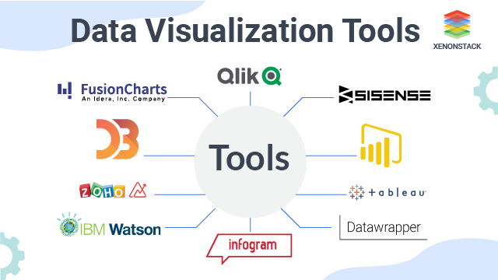

3.1 Understanding High Resolution

* Definition: Resolution refers to the number of pixels or points in an image or 3D model. Higher resolution means more pixels or points, which translates to finer detail and greater clarity.
* Measurement: In 2D images, resolution is measured in pixels (e.g., 1920x1080 pixels). For 3D models, it is often measured in vertices and polygons.

3.2 Importance of High Resolution:

* Detail and Clarity: High-resolution visualizations provide more detail, allowing for a clearer and more precise representation of the data. This is particularly important in fields like medical imaging, remote sensing, and engineering.
* Accurate Analysis: High resolution helps in accurately analyzing and interpreting data. For instance, in medical imaging, high-resolution scans can reveal finer anatomical details that are crucial for diagnosis and treatment planning​.
  1. Best Practices for High-Resolution Visualization:

3.3.1 Data Preparation

* Optimizing Data: Before visualization, optimize the data by cleaning and preprocessing to remove noise and artifacts. This ensures that the high resolution reveals meaningful details without distractions.
* Subsampling and Level of Detail (LOD): Use techniques like subsampling and LOD to manage data size and complexity. This approach helps in maintaining performance while still providing high-resolution detail where needed.
  + 1. Visualization Tools and Techniques
* Choosing the Right Tools: Use visualization tools that support high-resolution data. Tools like Blender, Para View, and MATLAB are capable of handling high-resolution images and 3D models effectively​ (ImageJ Wiki)​​ (Oak-Tree Technologies)​.
* Efficient Rendering: Employ efficient rendering techniques such as progressive rendering, where the visualization starts with a low-resolution overview and refines to higher resolution as more data is processed. This is useful in interactive applications where real-time performance is critical.
* Zoom and Pan Features: Implement zoom and pan features to allow users to explore high-resolution data interactively. This is especially useful in detailed datasets, such as geographical maps or large medical images.

3.3.3 Hardware Considerations

* High-Performance Hardware: Ensure you have the necessary hardware, including powerful GPUs and sufficient memory, to handle high-resolution data. High-resolution visualization can be computationally intensive and may require advanced hardware setups.
* Display Quality: Use high-resolution displays and monitors to view the visualizations. High-resolution data is best appreciated on screens that can accurately reproduce the detail and clarity.
  1. Application-Specific Considerations:

3.4.1 Medical Imaging

* DICOM Standards: For medical imaging, follow DICOM standards to ensure compatibility and accuracy. High-resolution medical images, such as MRI and CT scans, provide critical information for diagnosis and treatment planning.
* Segmentation and Analysis: Use high-resolution data for precise segmentation and analysis of anatomical structures, enabling better clinical outcomes​ (Oak-Tree Technologies)​.
  + 1. Engineering and Design
* CAD and CAM: In computer-aided design (CAD) and manufacturing (CAM), high-resolution 3D models are essential for precise engineering and design. Tools like Autodesk Maya and SolidWorks support high-resolution modeling and visualization.
* Simulation Accuracy: High-resolution data improves the accuracy of simulations, such as finite element analysis (FEA) and computational fluid dynamics (CFD), leading to better design decisions.
  1. Challenges and Solutions:

3.5.1 Data Size and Performance

* Large File Sizes: High-resolution data can result in large file sizes, which can be challenging to store and process. Use data compression techniques and efficient storage solutions to manage large datasets.
* Performance Optimization: Optimize performance by using techniques such as data streaming, parallel processing, and hardware acceleration. This ensures smooth and responsive visualization even with high-resolution data.

4. Avoid distracting elements:

When visualizing images and 3D data, minimizing distracting elements is crucial for ensuring clarity and focus on the main subject or information being presented. Here are some best practices to avoid distracting elements:

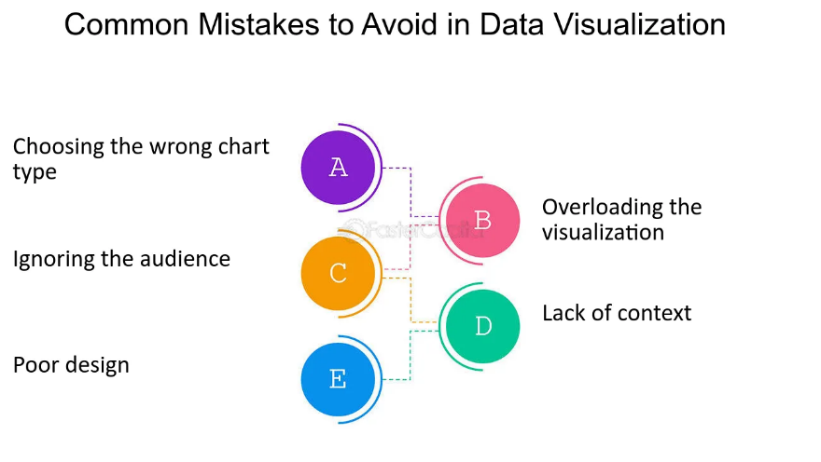

Simplify the Scene: Remove unnecessary elements from the scene that do not contribute to the main message or story. Keep the focus on the essential components of the image or data visualization.

Use Clean Backgrounds: Choose backgrounds that are simple and uncluttered. Busy backgrounds can compete for attention and detract from the main subject.

4.3 Control Lighting: Lighting plays a significant role in drawing attention to specific areas of an image or visualization. Use lighting techniques to highlight important features and minimize distractions elsewhere.

Contrast and Colour: Use contrast and colour strategically to guide the viewer's eye to the most critical elements. Make sure that important elements stand out against the background and other objects.

Depth of Field: In photography and 3D rendering, controlling the depth of field can help to isolate the main subject and blur distracting background elements.

Composition: Pay attention to composition principles such as the rule of thirds, leading lines, and framing to create a visually appealing and balanced image or visualization.

Reduce Clutter: Avoid overcrowding the scene with too many objects or data points. Prioritize the most relevant information and remove anything that adds unnecessary complexity.

Consistent Style: Maintain a consistent visual style throughout the image or visualization to create a cohesive and unified look. Inconsistencies can create distractions and confusion.

Use Depth Cues: In 3D visualizations, utilize depth cues such as perspective, shading, and occlusion to provide context and hierarchy, directing the viewer's attention to the focal points.

User Interaction: If the visualization is interactive, provide tools for users to control and manipulate the view to focus on specific areas of interest, reducing distractions.

5.Color Maps:

colormaps or colour scales, are essential tools for visualizing images and 3D data. They assign colours to numerical values in a dataset, allowing us to visually interpret the data and identify patterns, trends, and anomalies. However, using colour maps effectively requires consideration of best practices to ensure accurate and meaningful visualization. Here are some key points:

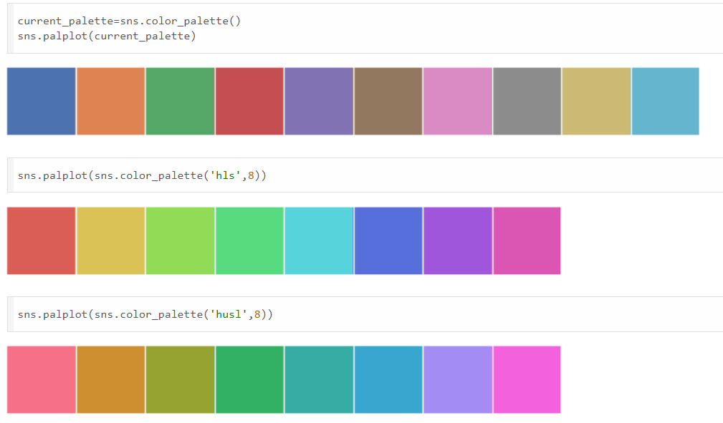

* Choose an Appropriate Colormap: The choice of colormap significantly impacts the interpretation of the data. Consider the nature of your data and the specific characteristics you want to highlight. For example, sequential colormaps are suitable for representing ordered data with low-to-high values, while diverging colormaps are useful for highlighting both low and high extremes around a central midpoint. Qualitative colormaps work well for categorical data.
* Consider Colour Blindness: Approximately 8% of men and 0.5% of women experience some form of colour blindness. Avoid colormaps with distinct colours that may be challenging for colour-blind individuals to differentiate. Choose colormaps that vary in intensity or utilize patterns or symbols in addition to colour.
* Ensure Perceptual Uniformity: Perceptual uniformity means that equal steps in data values correspond to equal perceptual steps in colour. Colormaps with perceptual uniformity ensure that the visual representation accurately reflects the underlying data distribution without introducing misleading artifacts.
* Avoid Over-saturation and Clipping: Overly saturated colours can distort the perception of data, while clipping occurs when colors at the extreme ends of the colormap are indistinguishable due to limited display capabilities. Choose colormaps with a balanced range of colors that are visually distinct and avoid extremes that may lead to clipping.
* Use Colormaps with Good Linearity: Colormaps with linear progression ensure that small changes in data values are represented consistently across the entire range. Non-linear colormaps can introduce visual distortions and make it difficult to interpret the data accurately.

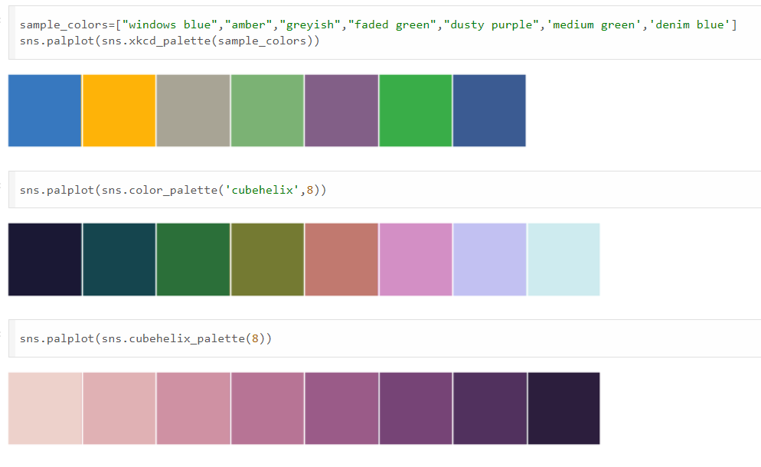

* Consider Cultural Associations: Different cultures may have varying associations with colors. Be mindful of cultural preferences and avoid colormaps that may carry unintended connotations or biases.
* Provide Colorbar and Labels: Always include a colorbar alongside the visualization to provide a reference for interpreting colors. Additionally, label the colorbar and axis to provide context and clarity regarding the meaning of the colors and the data they represent.
* Test and Iterate: Before finalizing a visualization, test different colormaps and settings to ensure that the chosen colormap effectively communicates the intended information. Solicit feedback from diverse users to identify any potential issues or improvements.

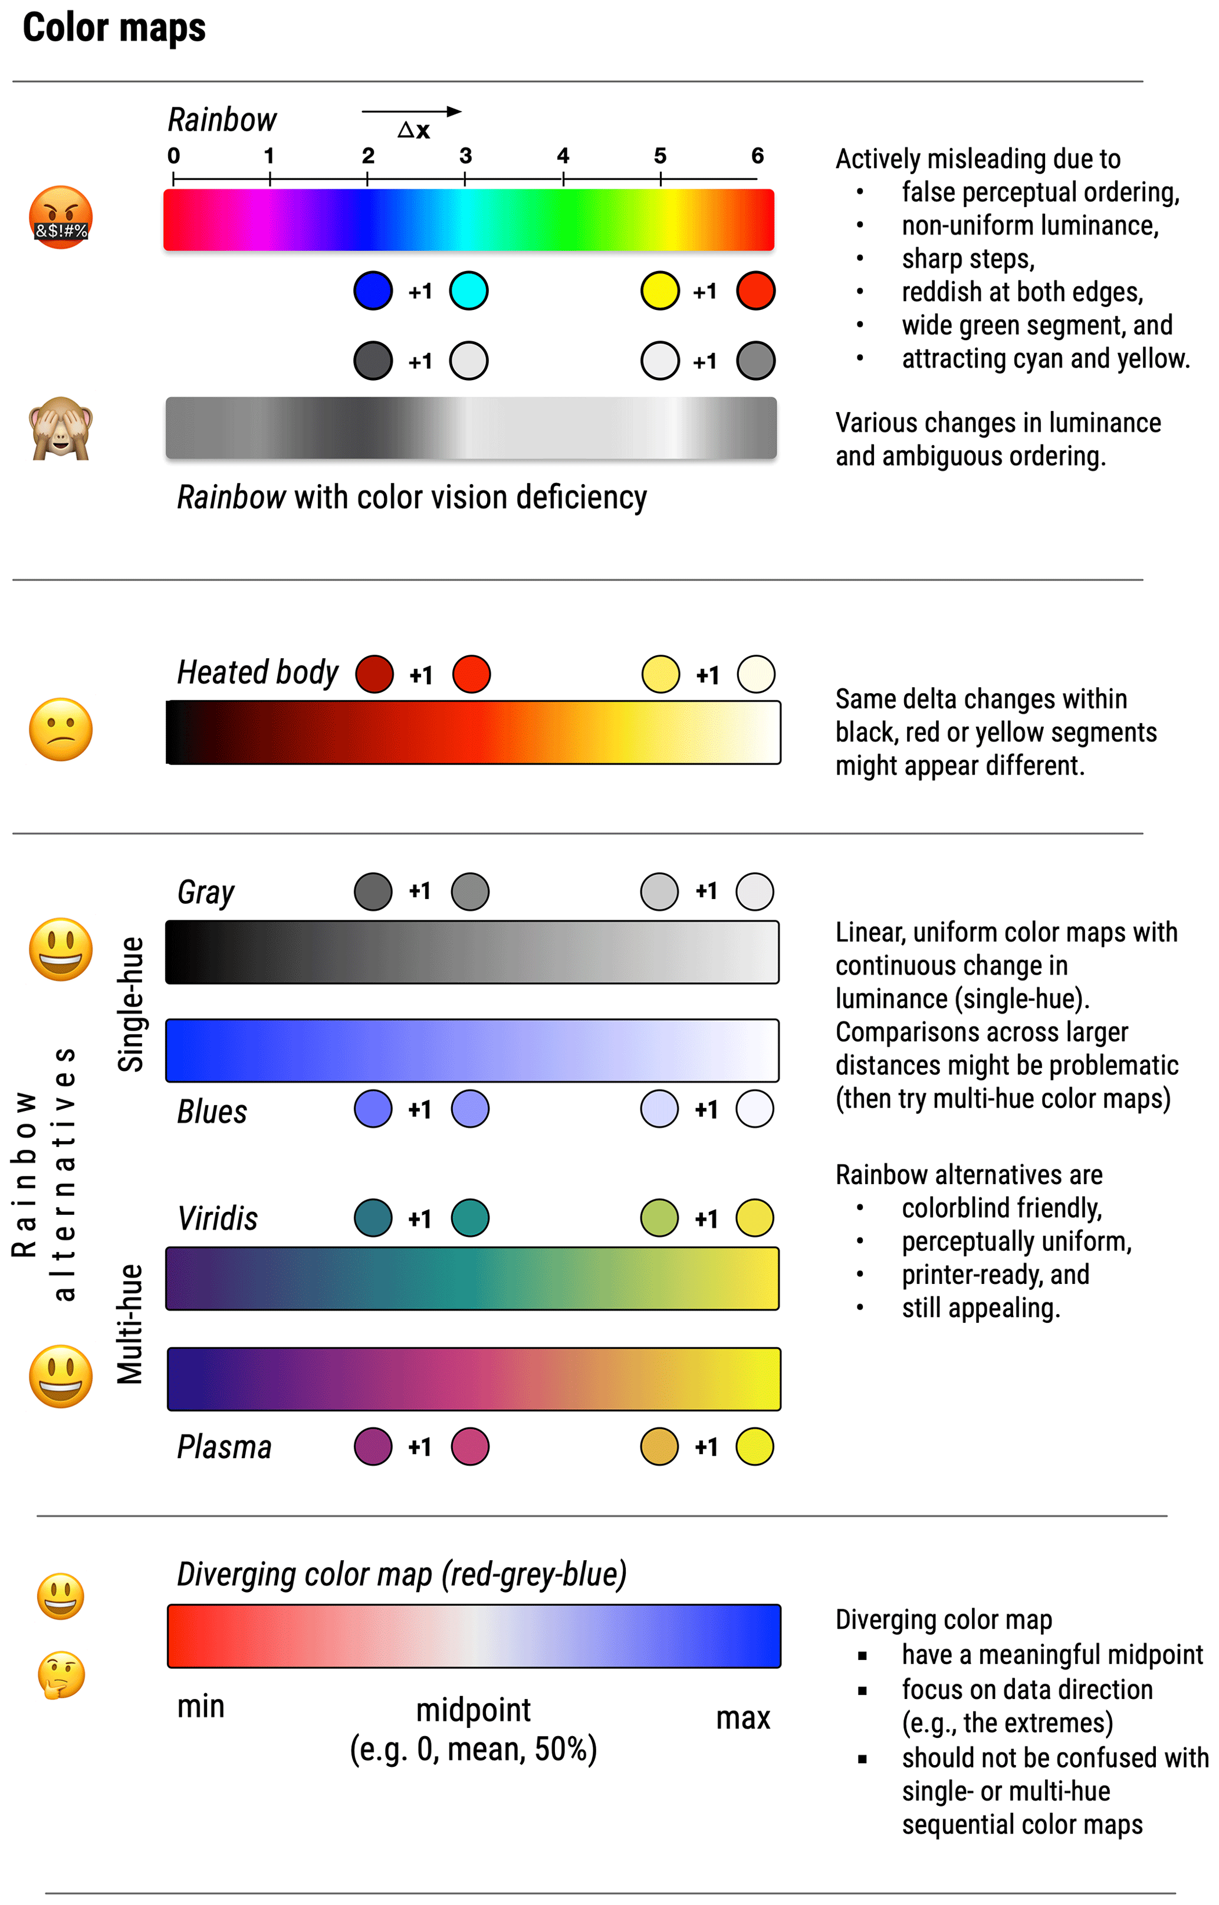

**Applications of Image and 3D Data Visualization**

Image and 3D data visualization are transformative technologies across diverse domains, enabling deeper insights, superior evaluation, and more engaging presentations of complex statistics. This report explores the key applications of these visualization strategies, highlighting their significance and impact across different fields.

**Medical Imaging**

# Diagnostic Imaging

* MRI and CT Scans: Utilizing 3D visualization for MRI and CT scan data provides detailed perspectives of internal body structures. This aids in diagnosing conditions such as tumors, fractures, and vascular diseases.
* Ultrasound: Enhanced visualization techniques provide clearer, real-time images of soft tissues, critical for monitoring pregnancies and diagnosing organ and blood flow conditions.

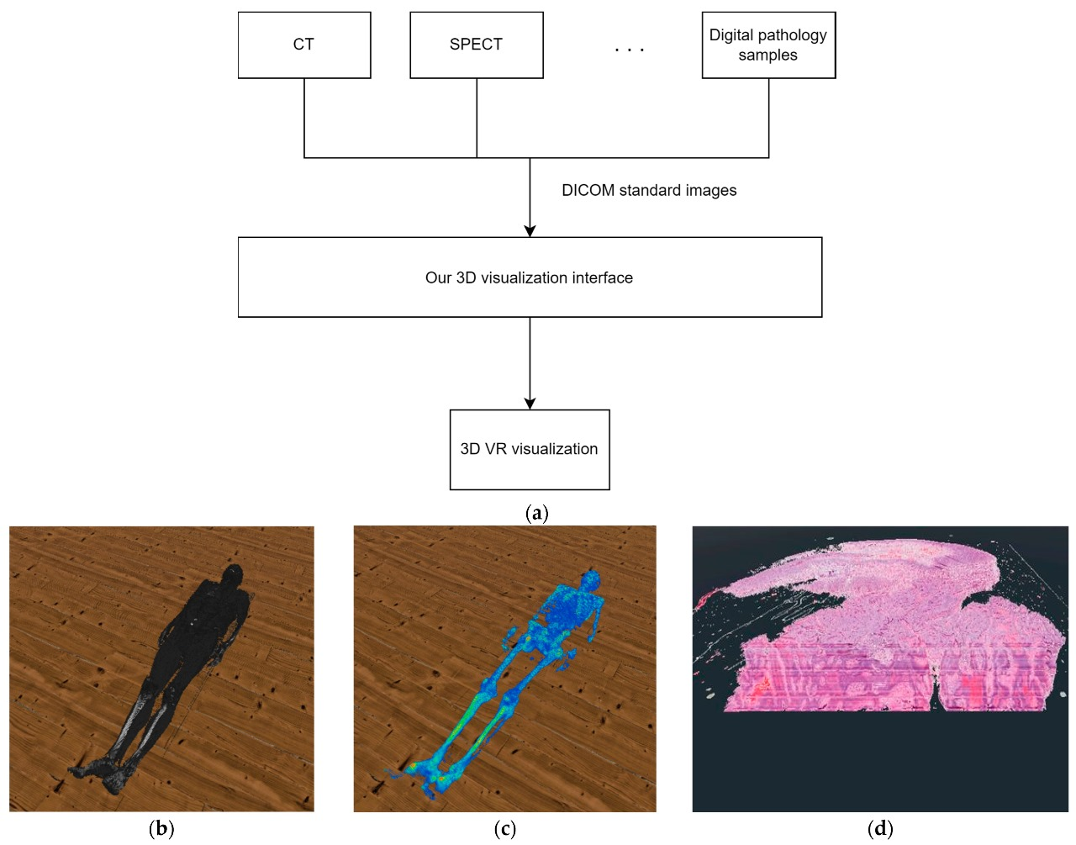

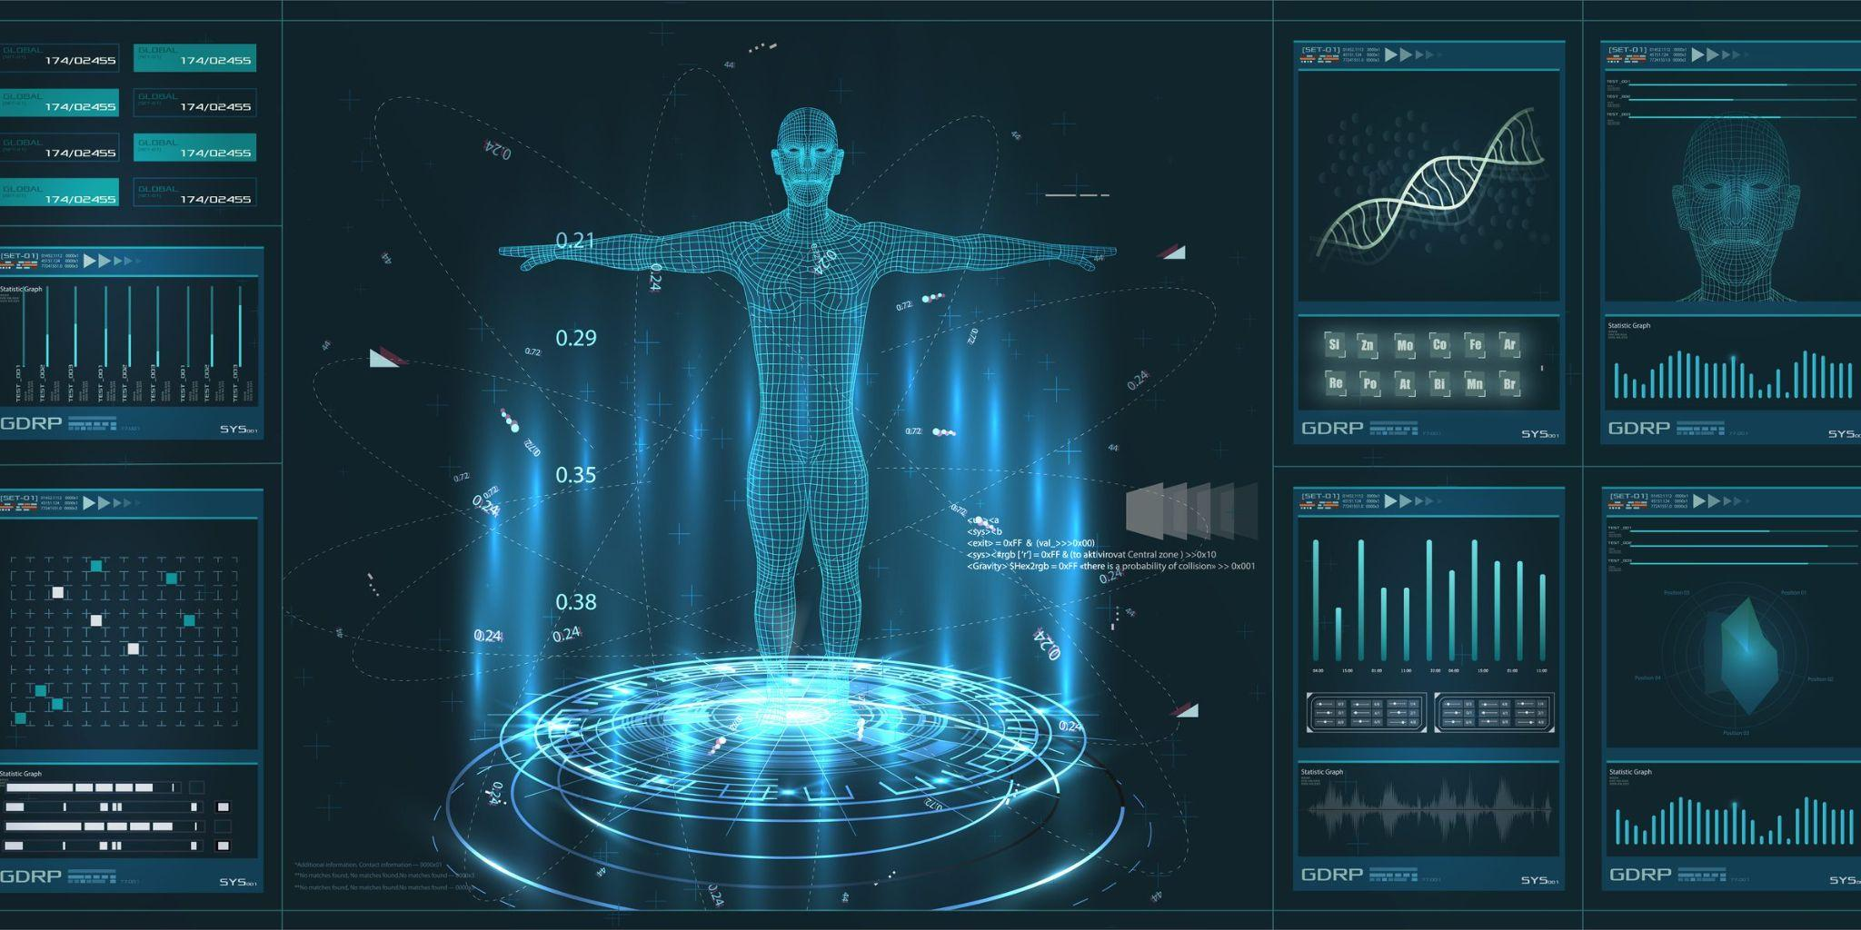

# Surgical Planning and Simulation

* Preoperative Planning: Surgeons use 3D models derived from patient scans to plan complex surgeries, improving accuracy and reducing risks.
* Augmented Reality (AR) in Surgery: AR systems overlay 3D anatomical data onto the patient's body during surgery, providing real-time guidance.

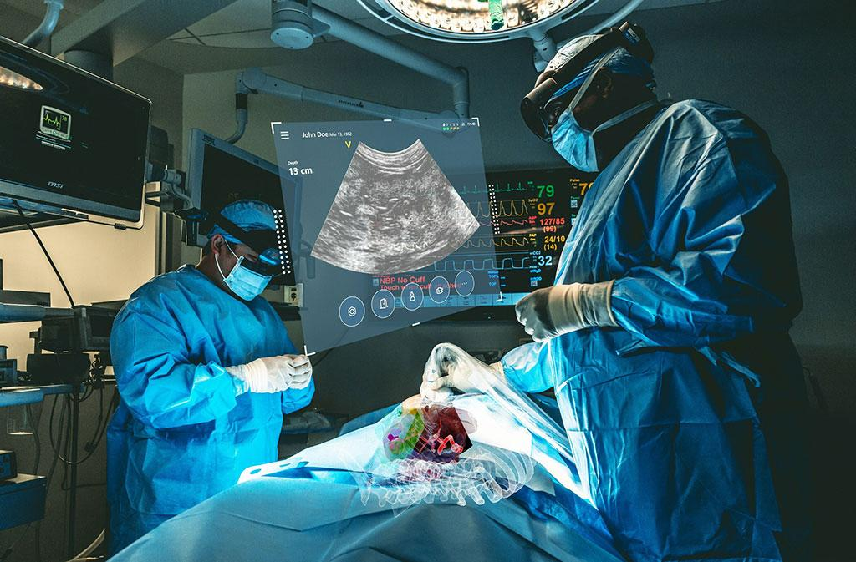

# Education and Training

* Anatomical Visualization: Medical students and professionals utilize detailed 3D models of human anatomy for better learning experiences.
* Virtual Reality (VR) Simulations: VR environments simulate surgical procedures and medical scenarios, offering hands-on practice in a risk-free setting.

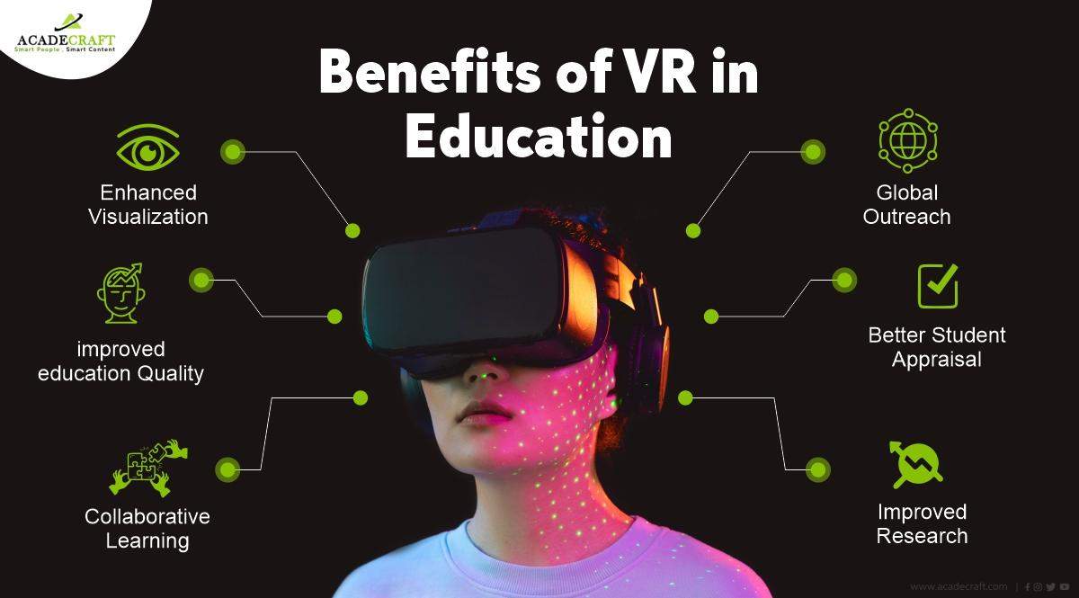

**Scientific Visualization**

# Environmental Science

* Climate Modeling: Visualizing climate data in 3D helps scientists understand and predict changes in weather patterns, global temperatures, and sea levels.
* Ecological Studies: 3D visualization of ecosystems and habitats aids in monitoring biodiversity and the impact of environmental changes.

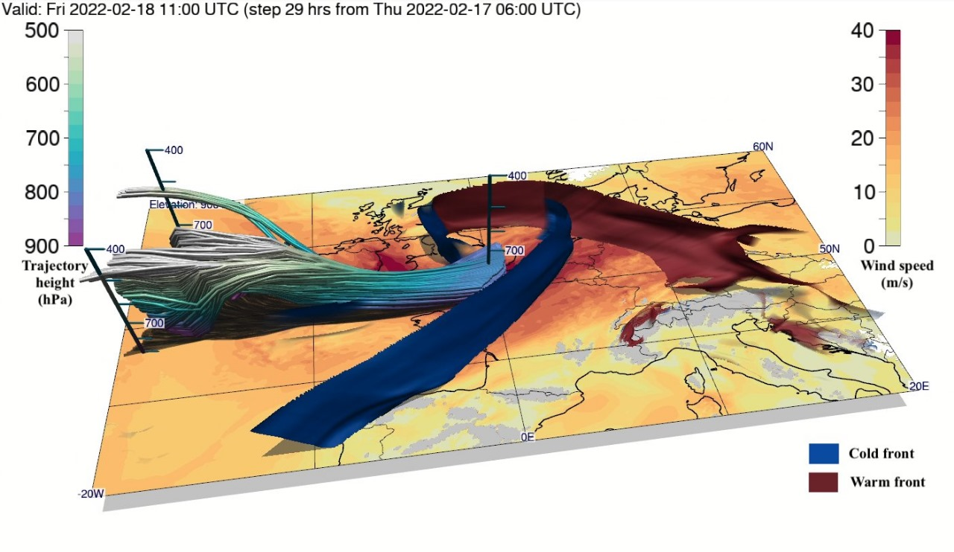

# Physics and Astronomy

* Particle Physics: Visualization tools assist in analyzing data from particle accelerators, revealing insights into fundamental particles and forces.
* Astronomical Data: 3D visualization of celestial bodies and phenomena enables astronomers to explore the universe, from planetary systems to distant galaxies.

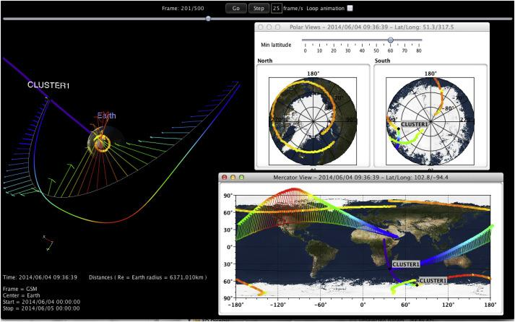

# Engineering and Fluid Dynamics

* Structural Analysis: Engineers use 3D models to visualize and analyze stress, strain, and deformation in materials and structures.
* Fluid Dynamics: Simulating fluid flow in 3D helps in studying aerodynamics, weather systems, and ocean currents, improving designs in automotive and aerospace industries.

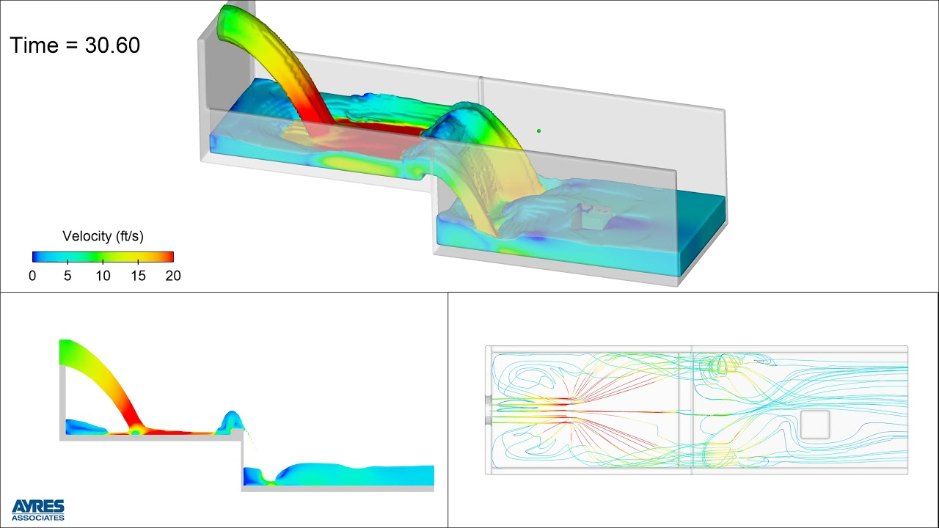

**Virtual Reality (VR) and Augmented Reality (AR)**

# Entertainment and Gaming

* Immersive Experiences: VR and AR provide engaging and interactive experiences in gaming, enabling players to explore virtual worlds and interact with digital objects.
* Cinema and Animation: 3D visualization and VR technologies are used in creating realistic visual effects and immersive cinematic experiences.

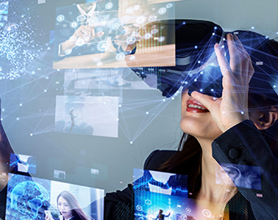

# Education and Training

* Interactive Learning: VR and AR applications create interactive and immersive learning environments, making education more engaging and effective.
* Professional Training: Industries such as aviation, military, and healthcare use VR simulations for training, allowing personnel to practice skills in realistic scenarios.

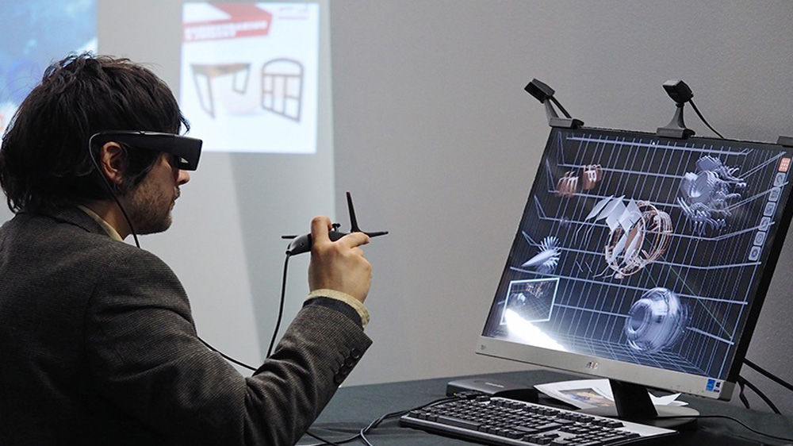

# Retail and Marketing

* Virtual Showrooms: AR applications allow customers to visualize products in their own environment before purchasing, enhancing the shopping experience.
* Interactive Advertising: AR campaigns create interactive and engaging advertisements, attracting more customers and increasing brand engagement.



**Computer-Aided Design (CAD)**

# Engineering and Manufacturing

* Product Design: CAD software with 3D visualization capabilities enables designers to create and test virtual prototypes, reducing the need for physical models and speeding up the design process.
* Manufacturing Processes: Visualization of manufacturing workflows and assembly lines helps in optimizing production and identifying potential issues.

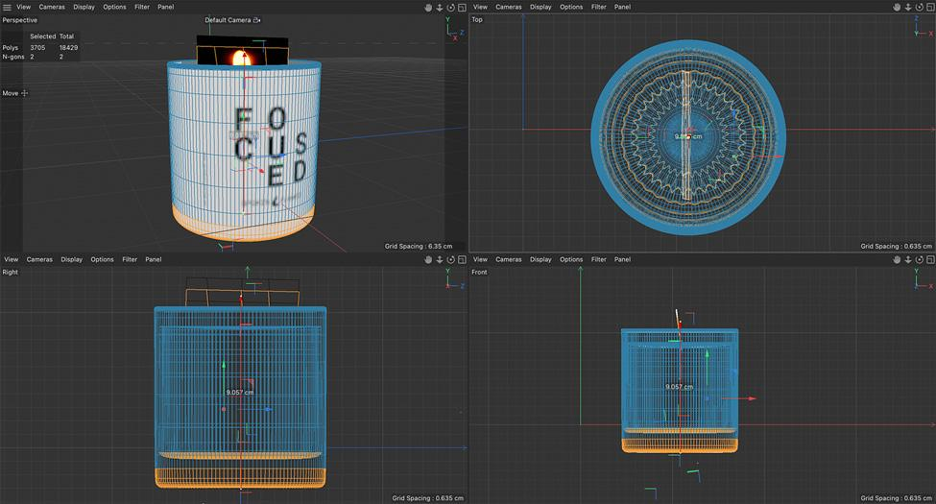

# Architecture and Construction

* Building Information Modeling (BIM): BIM integrates 3D models with data on building materials, costs, and timelines, improving collaboration and project management in construction projects.
* Virtual Walkthroughs: Architects and clients can explore building designs through virtual walkthroughs, allowing for better understanding and feedback on the design.

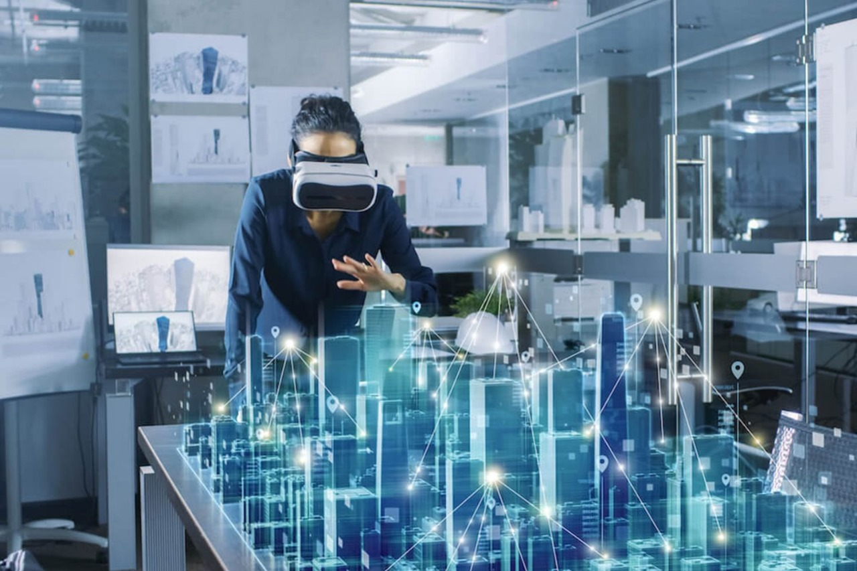

**CONCLUISION**:  
**A. Introduction and Overview**In this comprehensive analysis, we embarked on a journey to visualize images and 3D data, delving deep into the intricacies of complex datasets. Our exploration spanned four pages, each revealing unique perspectives and insights into the underlying structures and relationships within the data.  
  
**B. Uncovering Patterns and Trends**Through meticulous visualization techniques, we uncovered a myriad of patterns and trends embedded within the data. From subtle variations to pronounced clusters, each visualization offered a glimpse into the underlying dynamics shaping the dataset. These insights serve as a foundation for understanding the nuances and complexities inherent in the data.  
  
**C. Identifying Anomalies and Outliers**Beyond patterns and trends, our analysis unearthed anomalies and outliers that defy conventional expectations. These outliers, often overlooked in traditional analyses, carry valuable insights into unique phenomena and exceptions within the dataset. By highlighting these anomalies, we illuminate potential areas of further investigation and discovery.  
  
**D. Implications and Future Directions**  
  
Our exploration of images and 3D data through visualization techniques has far-reaching implications across various fields, from healthcare to finance to environmental science. The insights gained from this analysis can inform decision-making, drive innovation, and inspire new avenues of research. Looking ahead, the integration of advanced visualization methods and emerging technologies promises to unlock even deeper insights and opportunities for exploration.  
  
This multi-page conclusion encapsulates the key findings and implications of our analysis, providing a comprehensive overview of the significance of visualizing images and 3D data.

|  |  |
| --- | --- |
|  |  |